Jenkins Continuous Integration 201

For Creating slaves for Jnekins we need 1 slave machine (VMs)

Since we don’t have more VM ,I ll be making use of docker container as a slave machine

So first we will be installing Docker in our master machine.

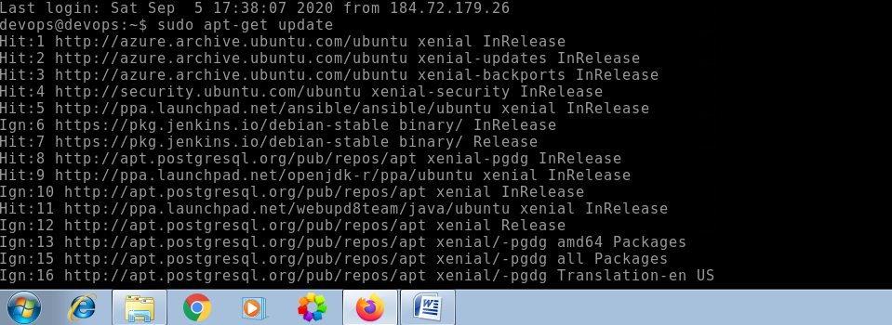

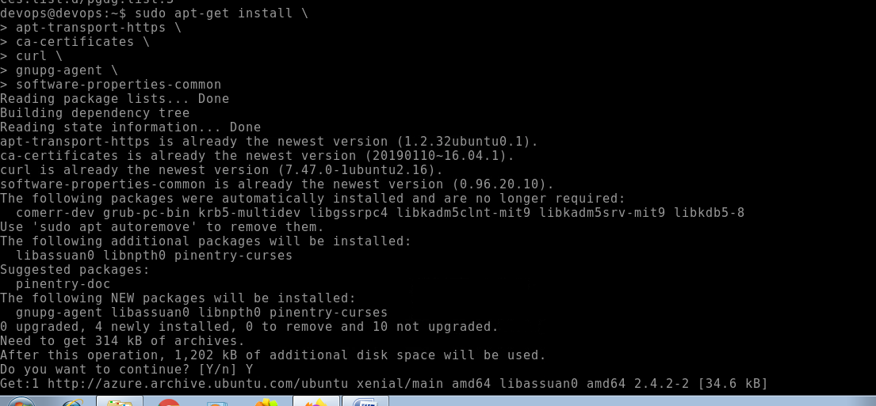

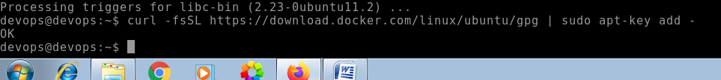

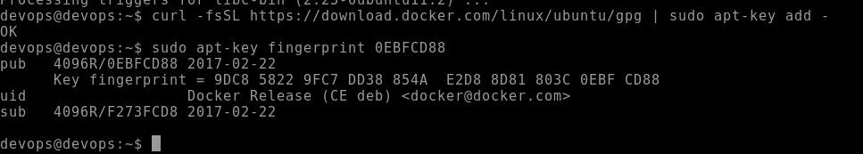

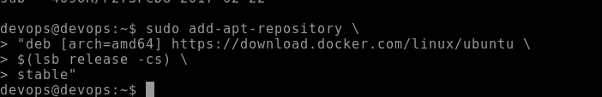

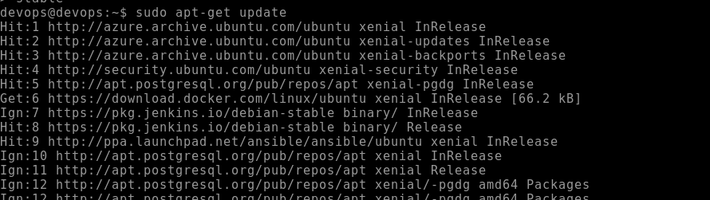

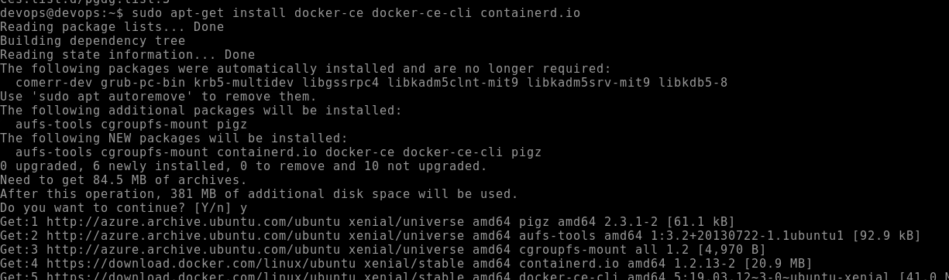

We could see that now the latest version of docker is installed successfully.

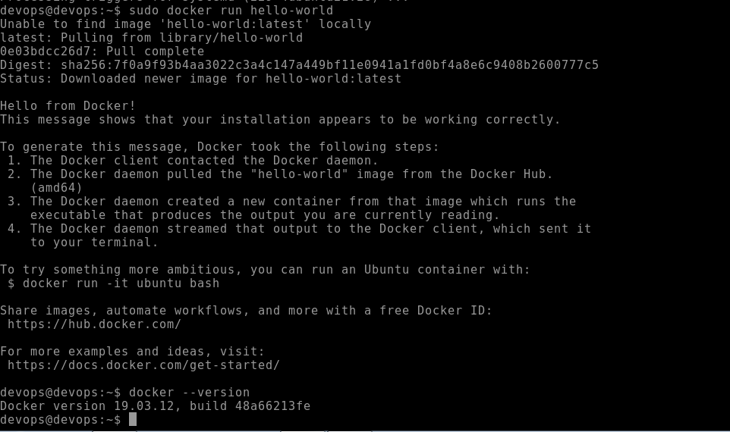

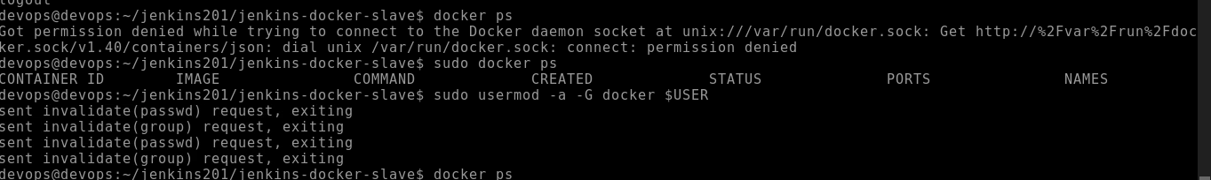

Then open the docker service file

/lib/system/system/docker.service Search for ExceStart and Replace the line with following

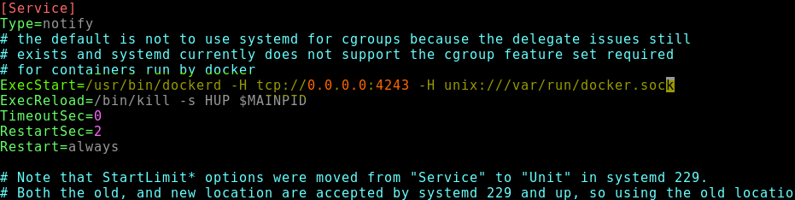

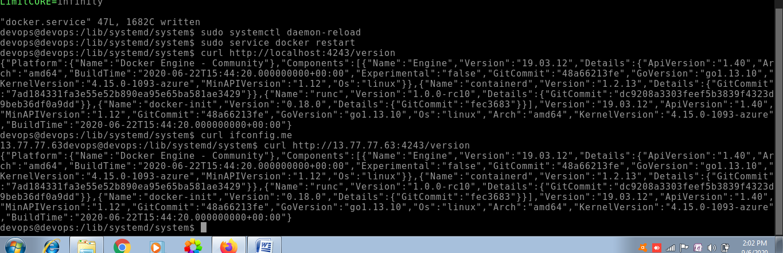

Now will be creating Jenkins Agent Docker Image

Docker image for maven

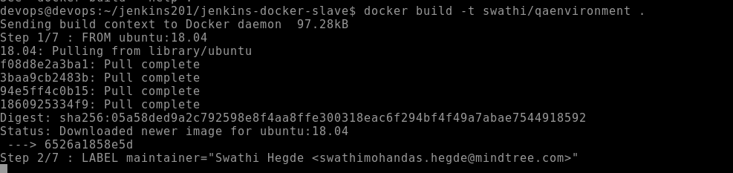

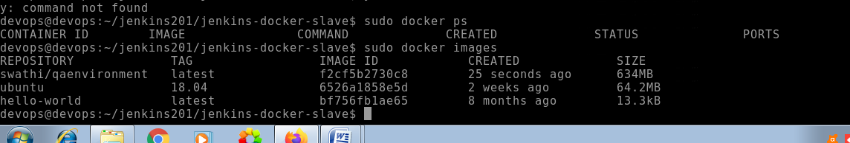

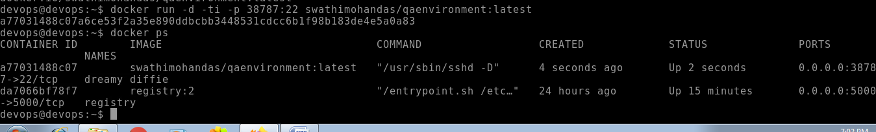

Now we will be installing docker cloud plugin in Jenkins

Manage Jenkins -🡪 Manage plugins

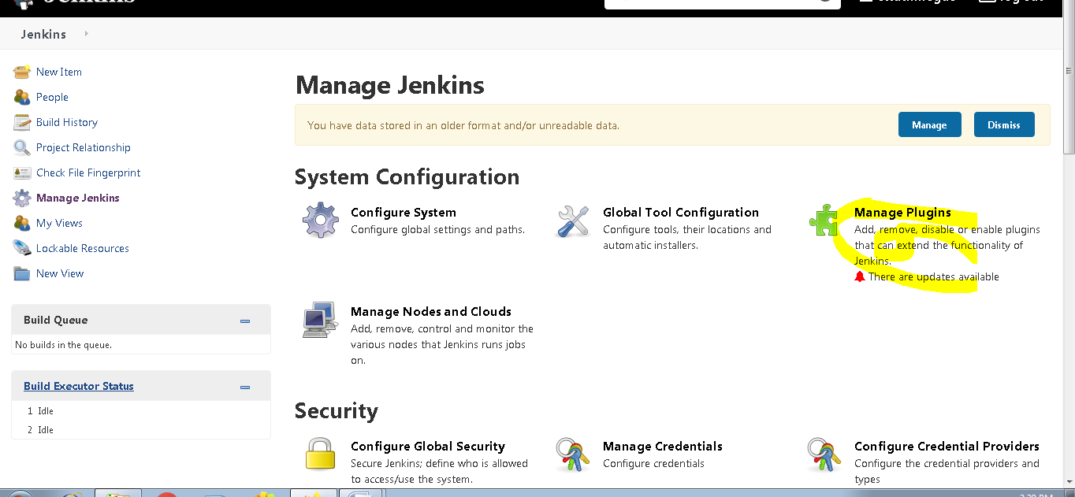

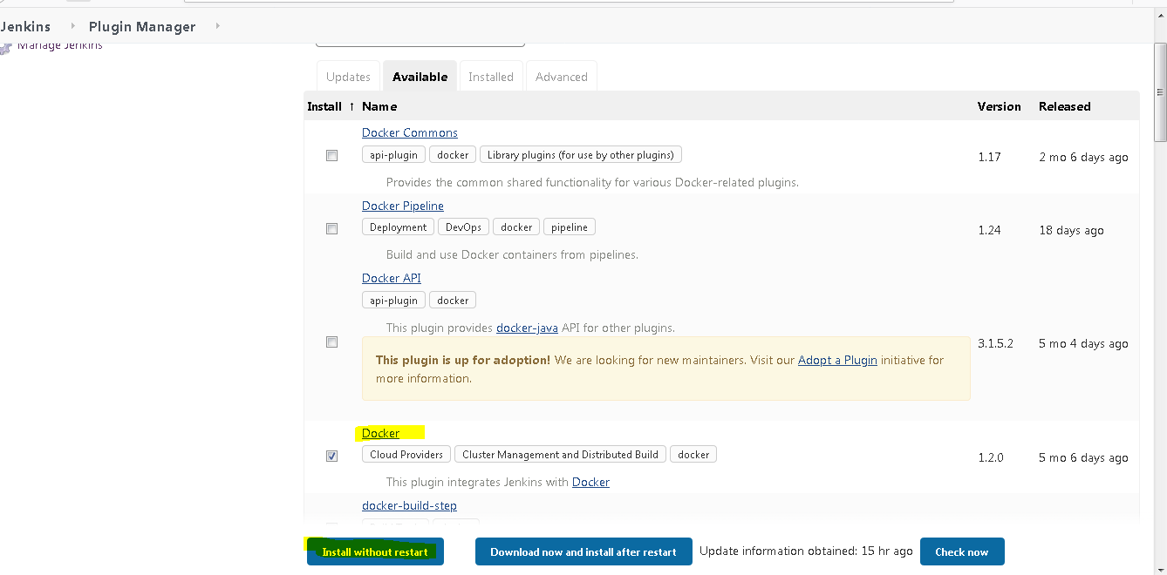

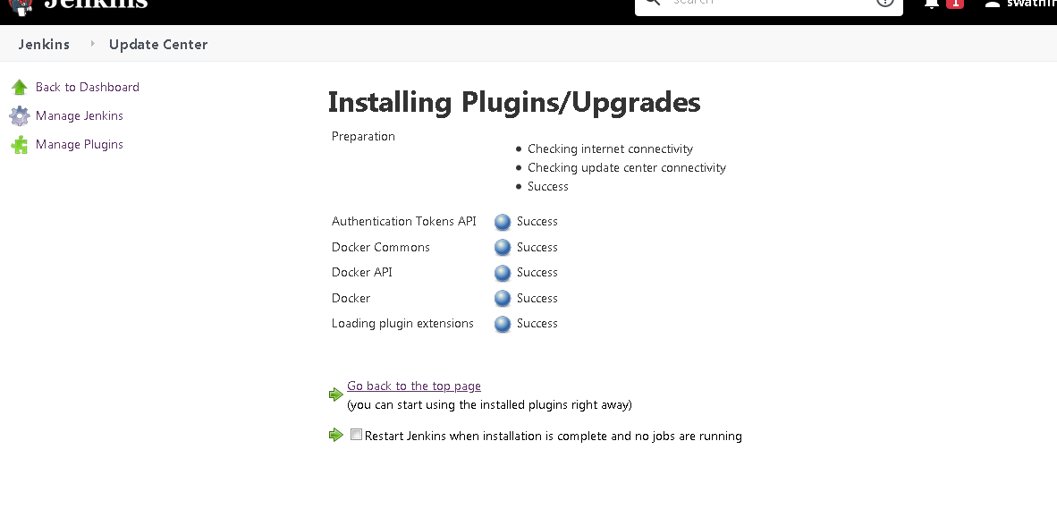

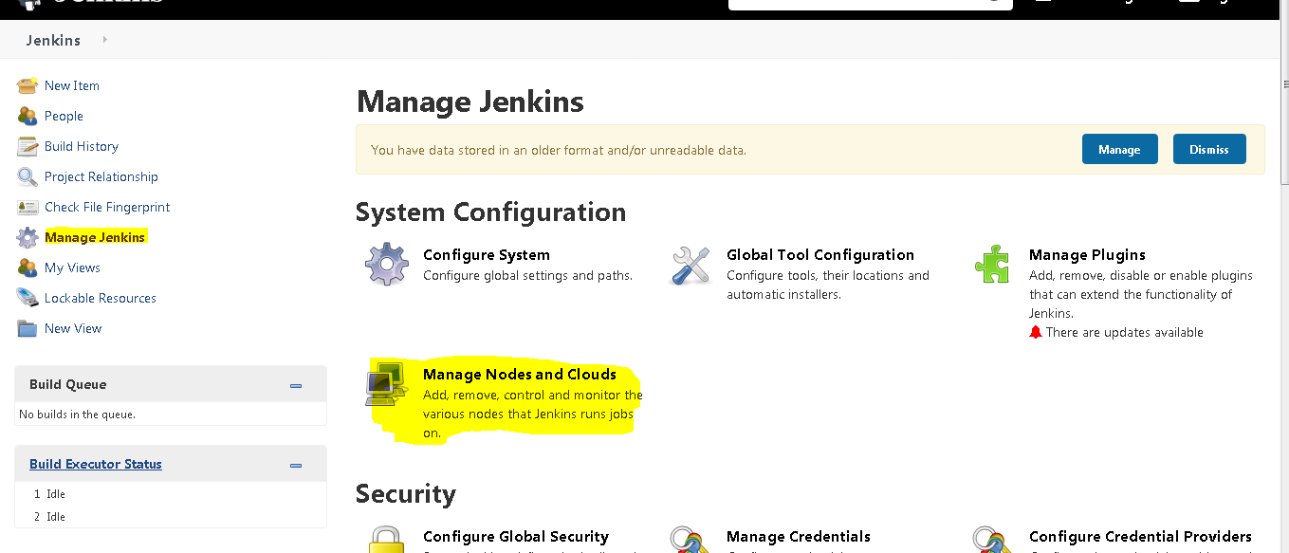

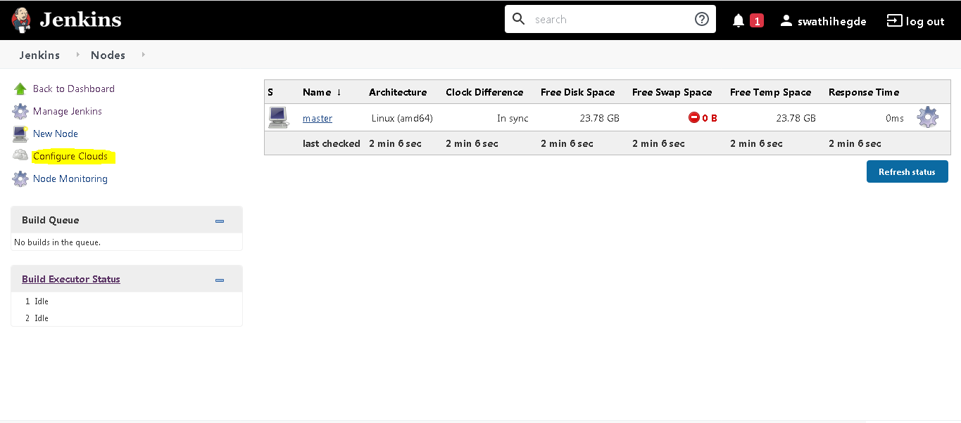

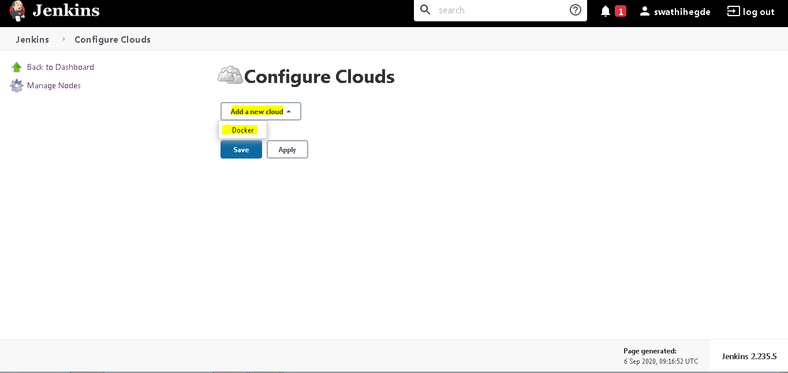

To get the docker URI

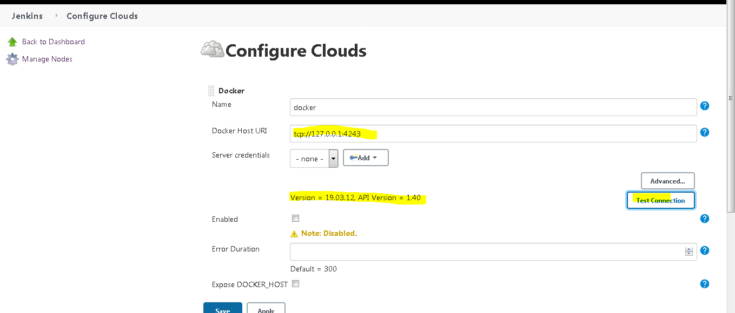

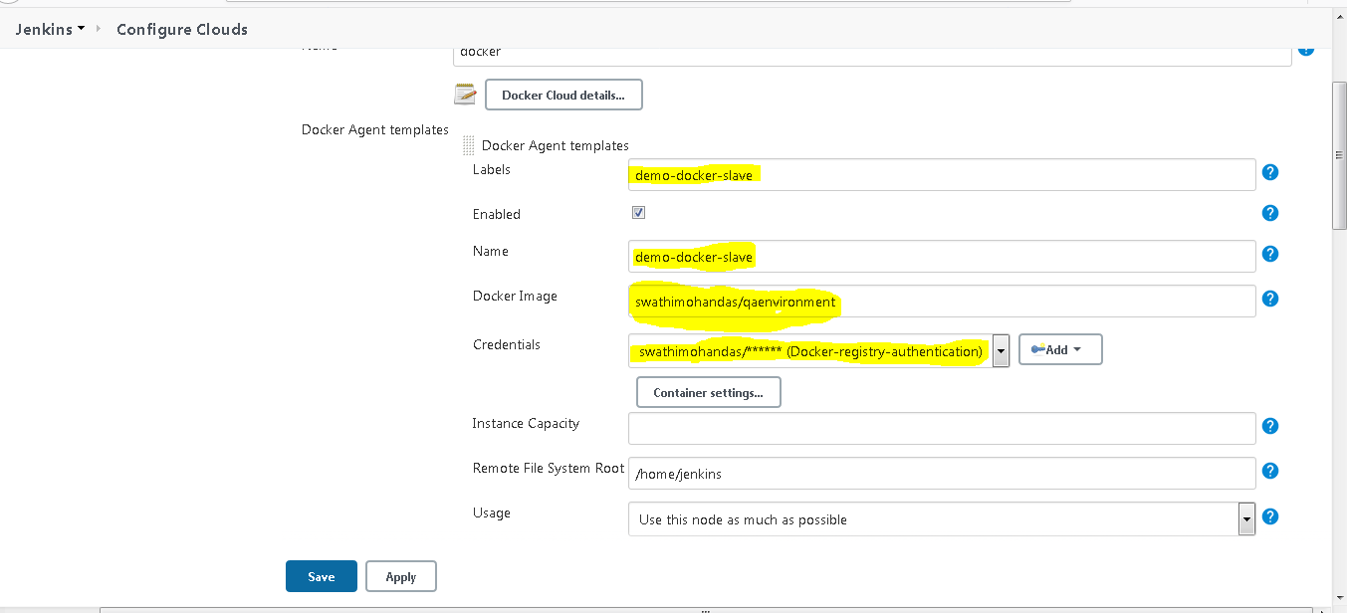

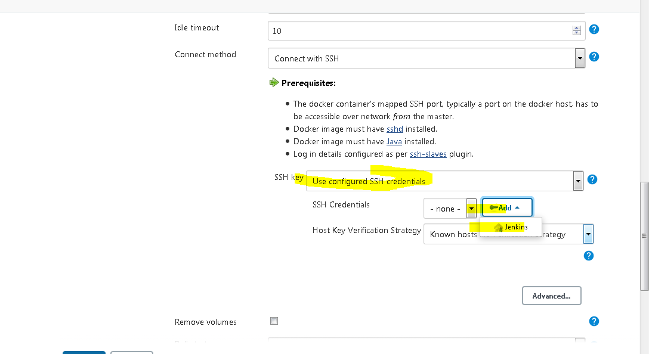

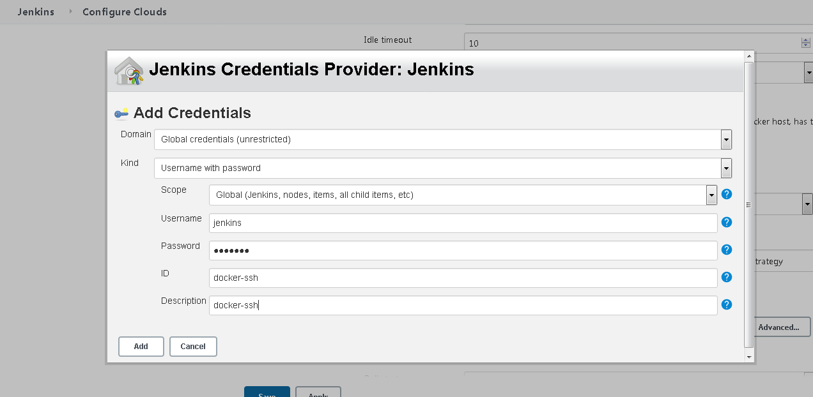

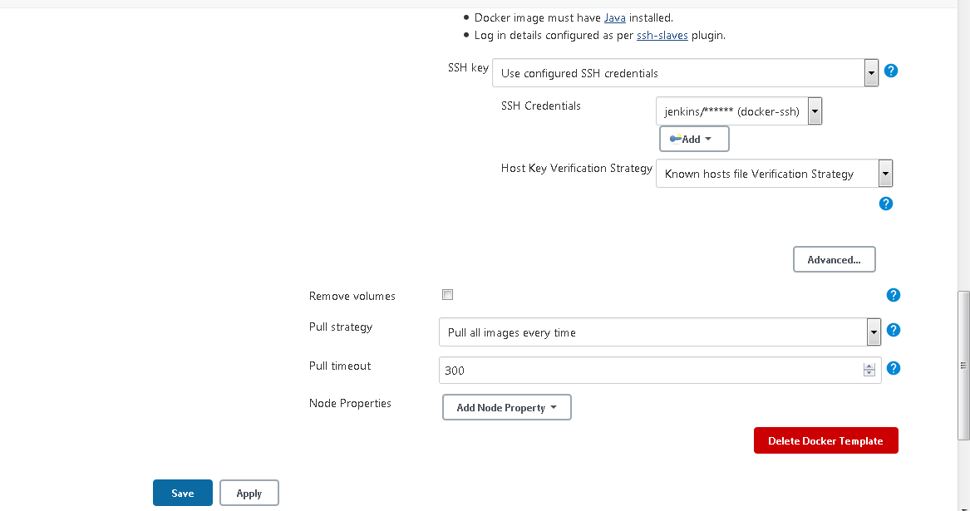

Now we can verify the same by running 1 job

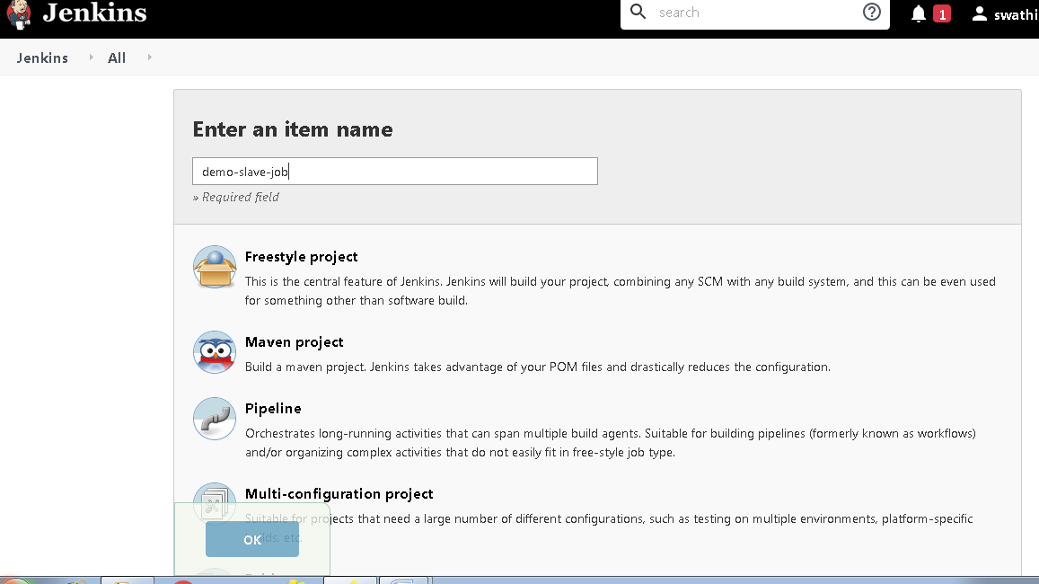

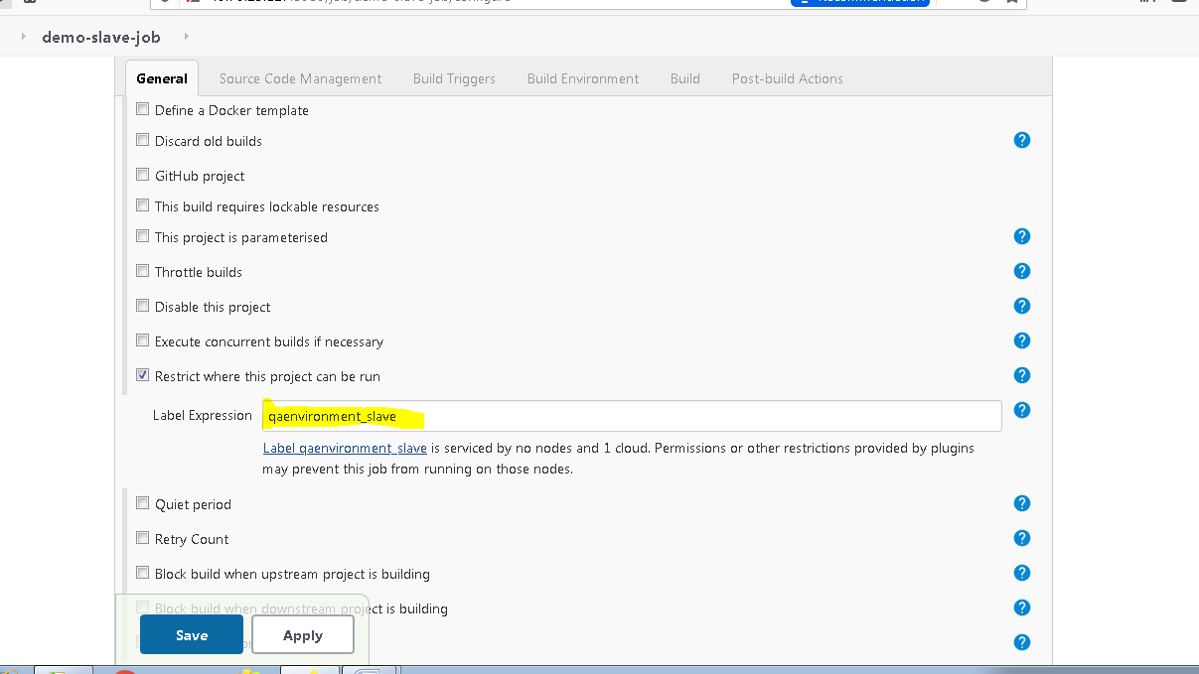

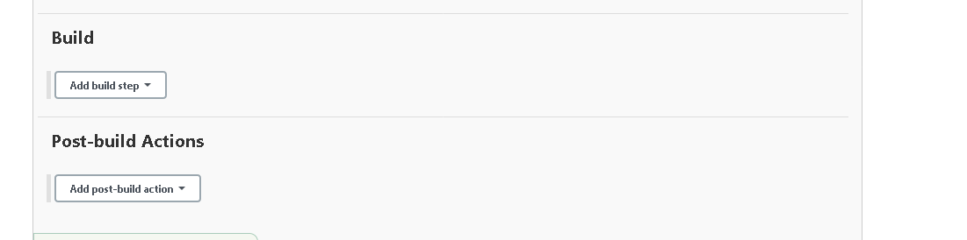

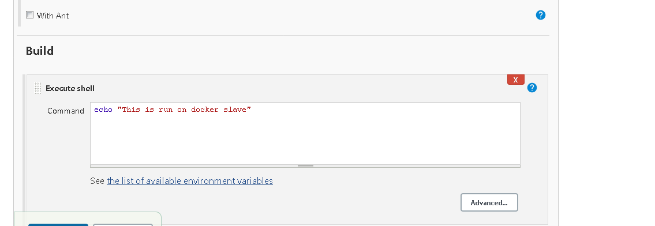

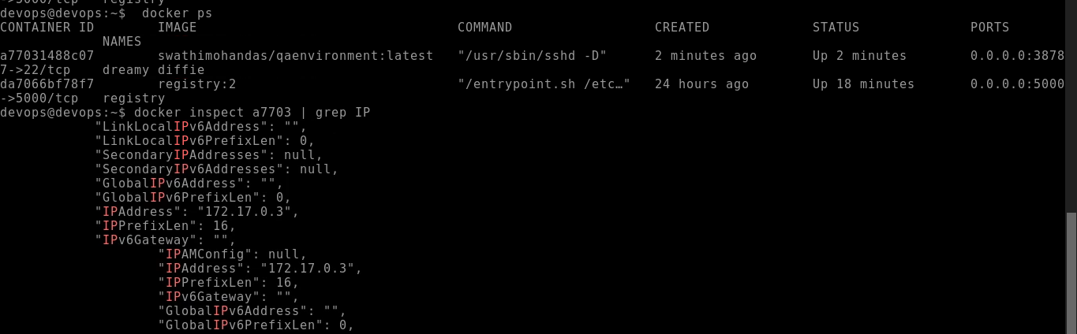

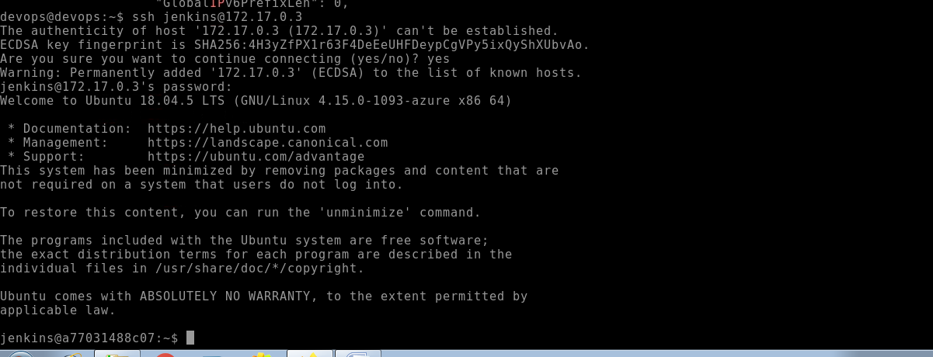

Below is the console output of a test build job for slave

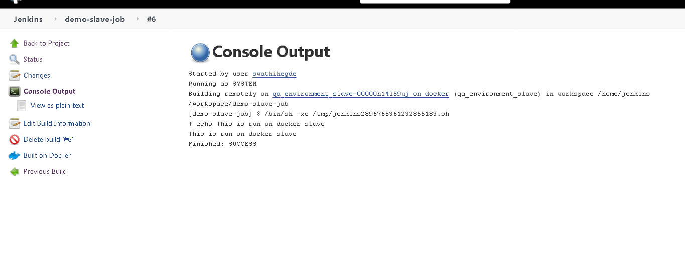

Now we have setup the slave environement

**Next we will be configuring the email with Jenkins**

**Fisrt I ll be creating 1 mail server as follows**

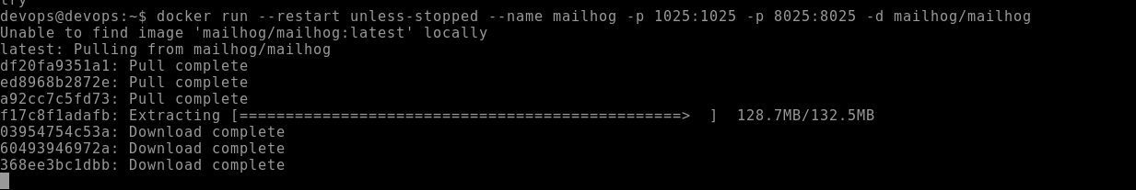

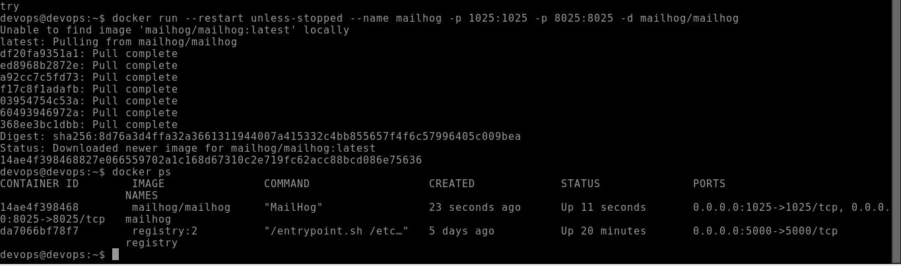

**Chcek the port 8025 (Email server is setup as follows)**

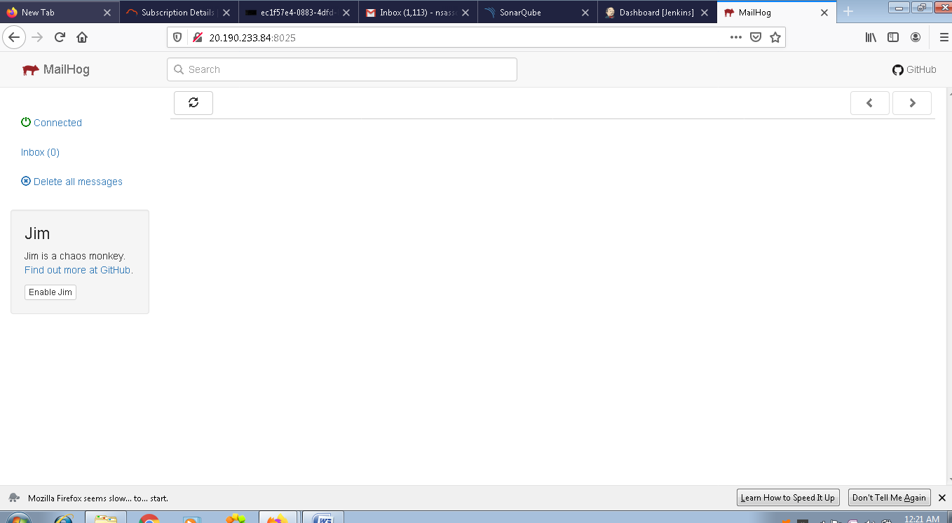

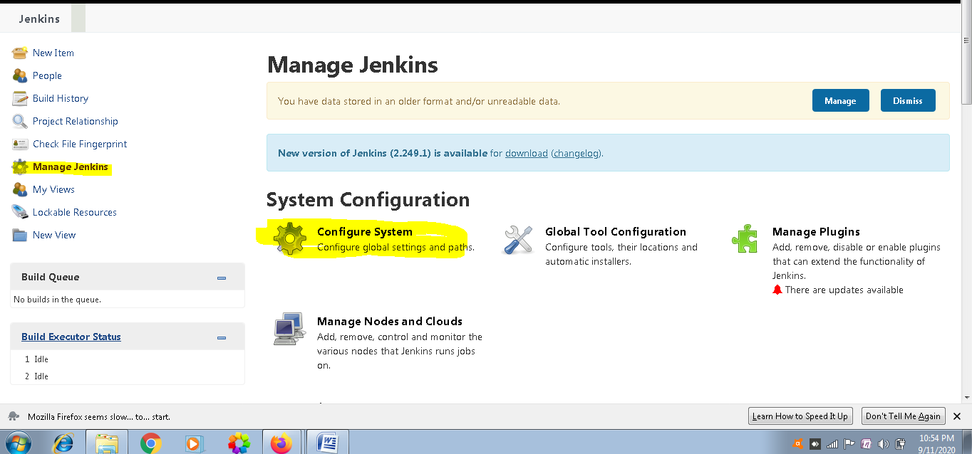

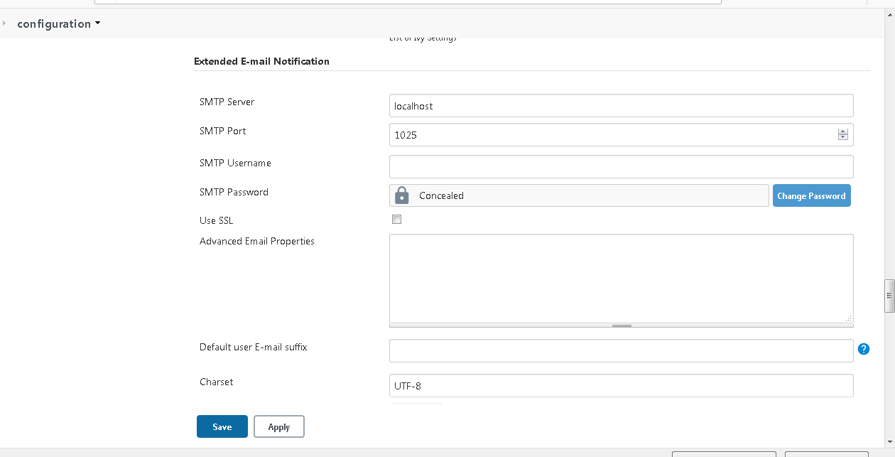

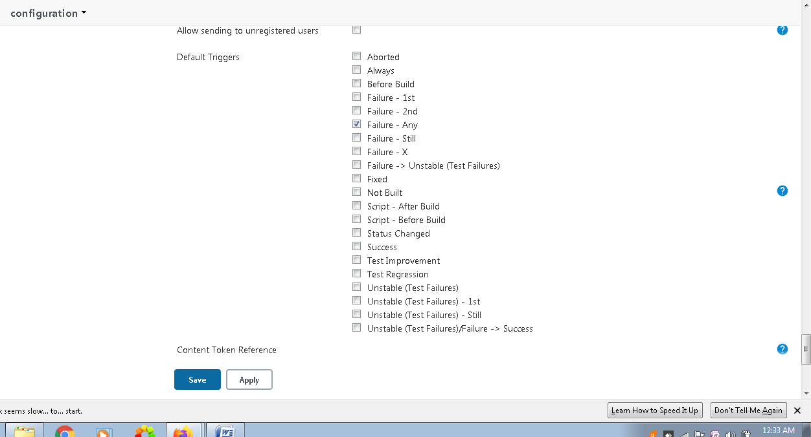

**Now We will be installing Build Pipeline Plugin as follows**

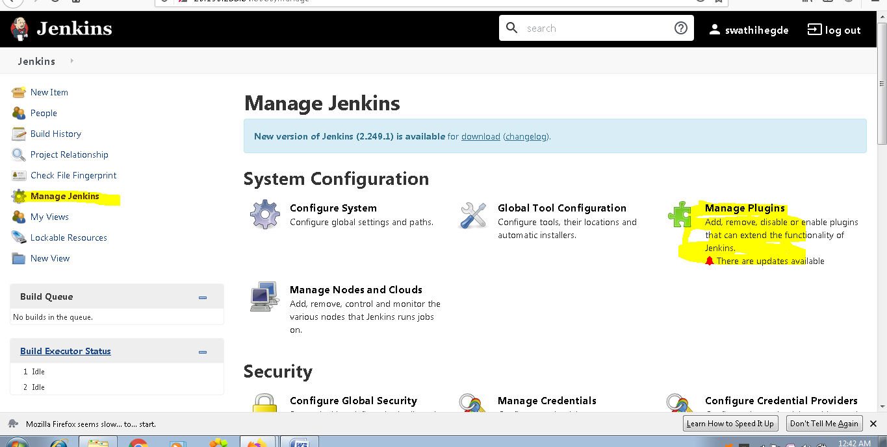

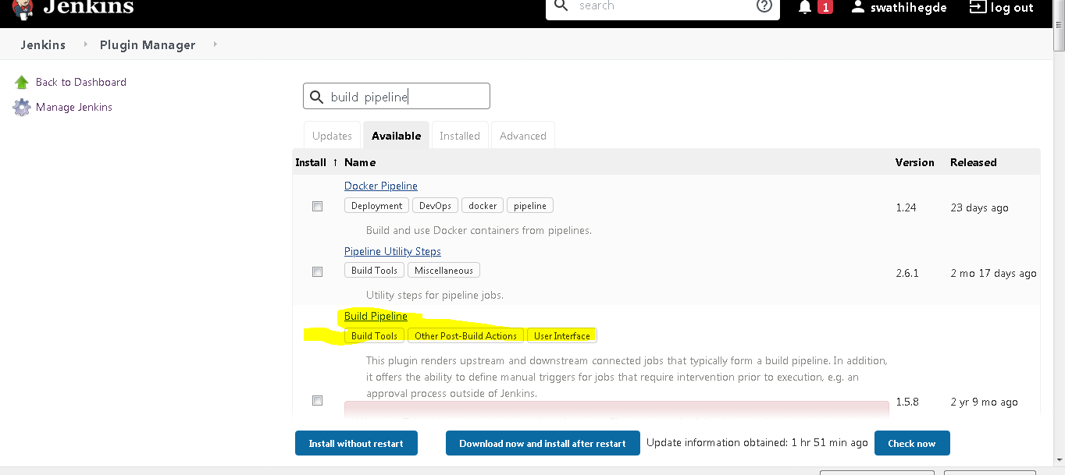

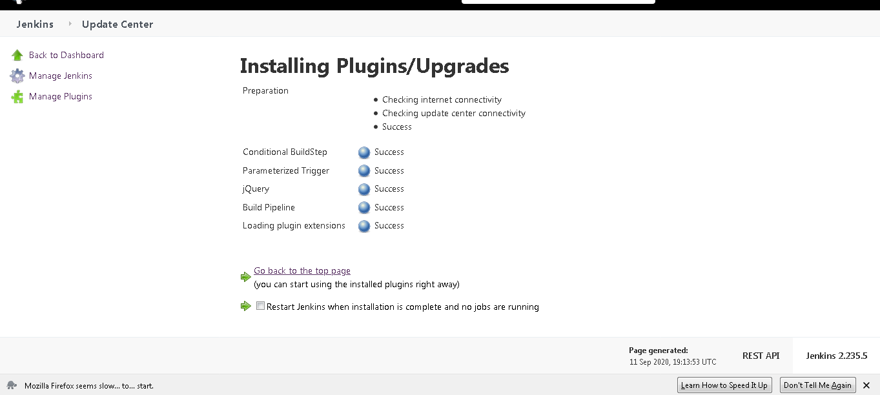

**We will be doing the Jfrog and Sonar qube setup as well**

Now we will set up the JFrog server in our VM

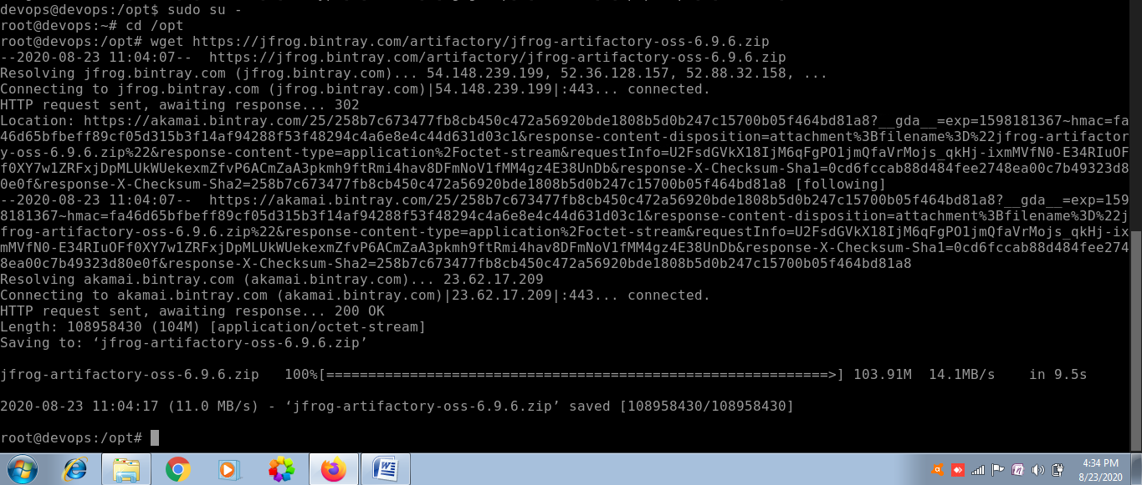

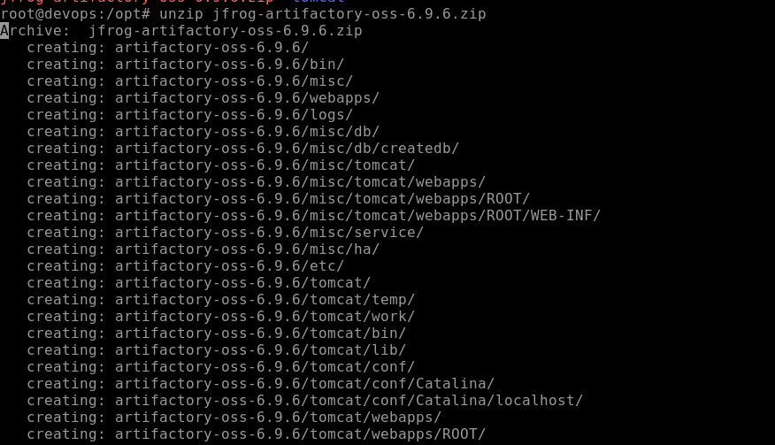

After unzipping now we will go to bin directory and start the services

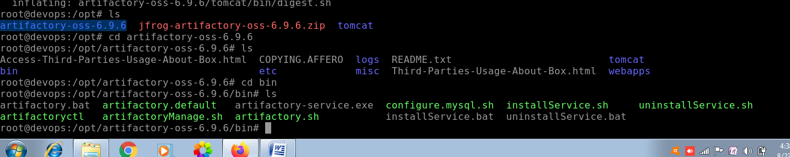

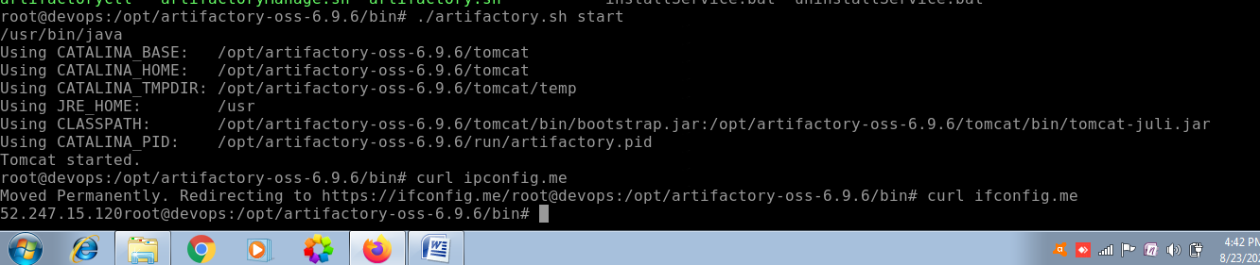

Now we could see that the JFROG Artifactory server is setup at port 8081 as follows

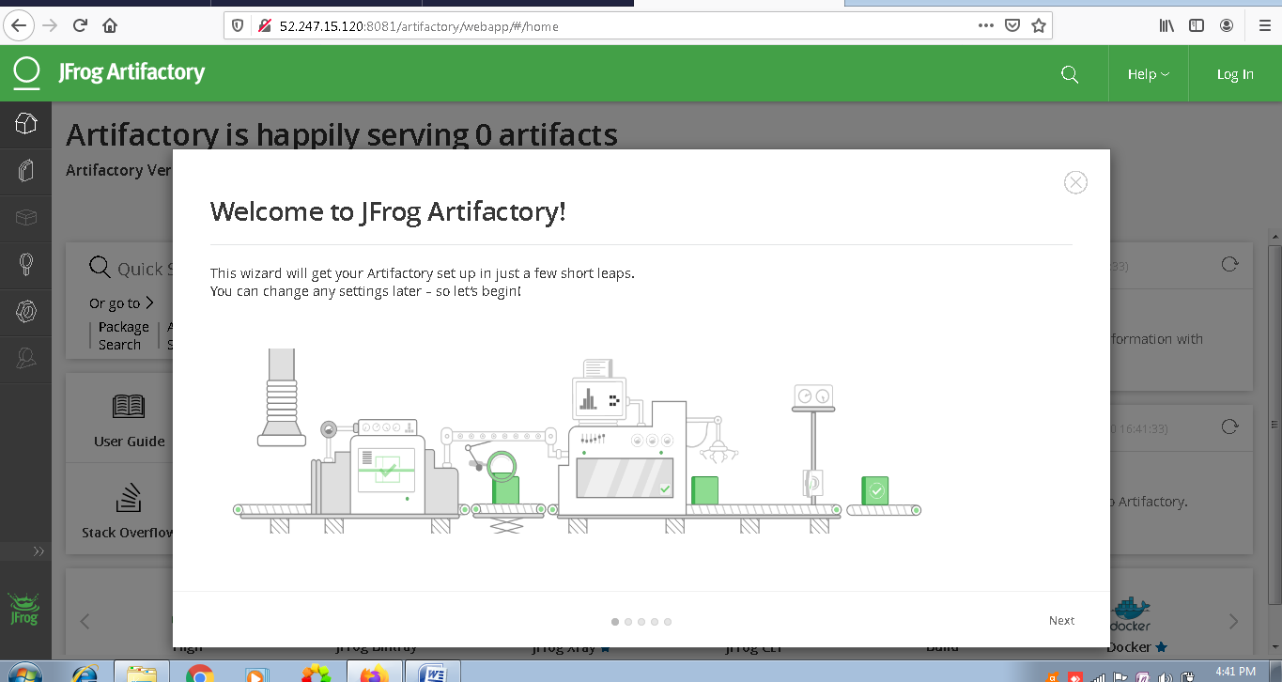

Then click next and setup the admin password as follows

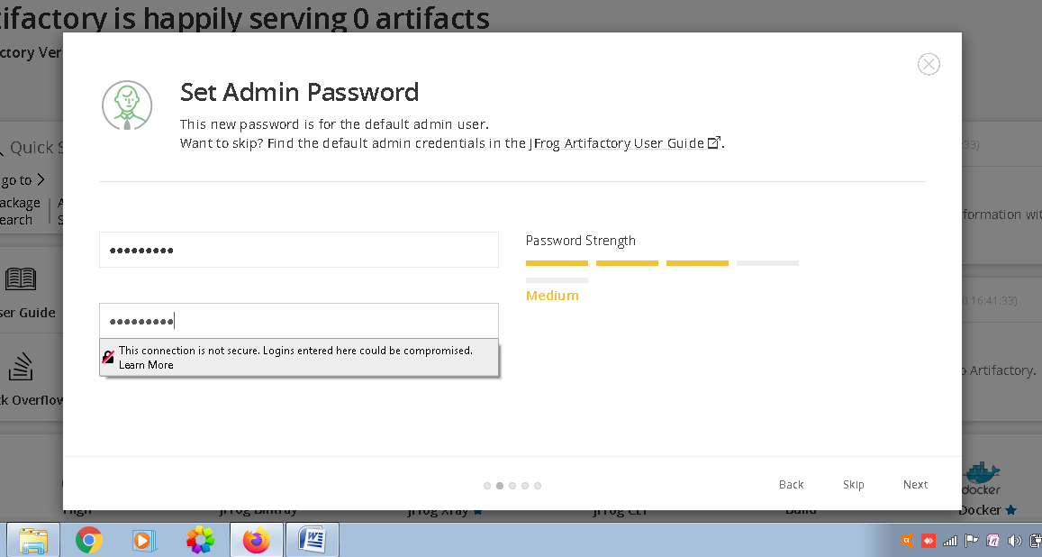

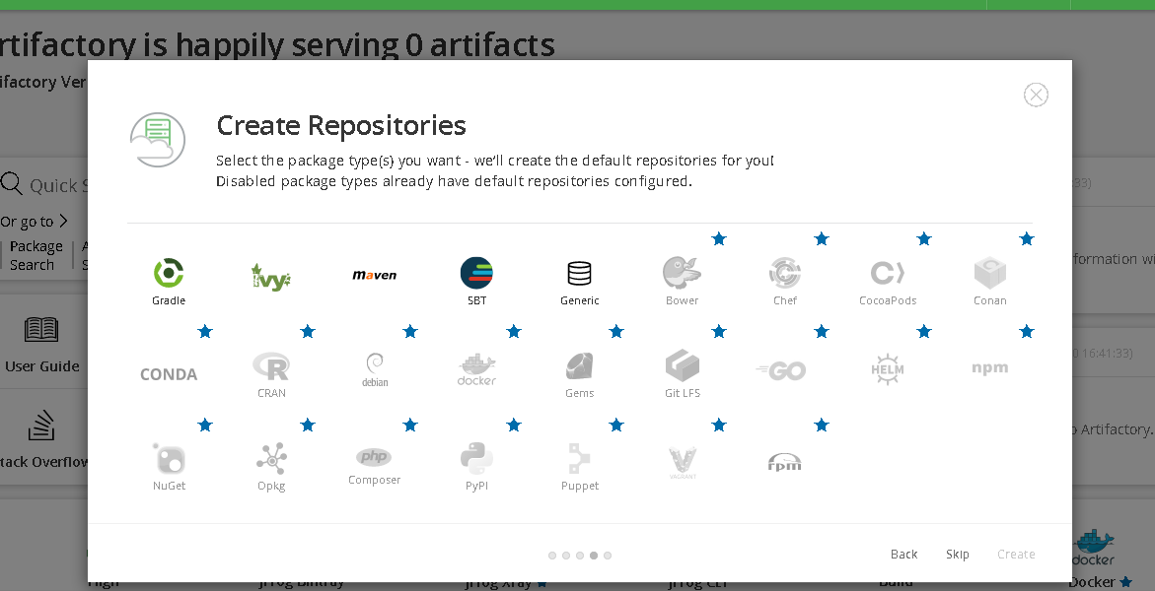

Since we are going to build maven project hence I will be selecting Maven and then click on create

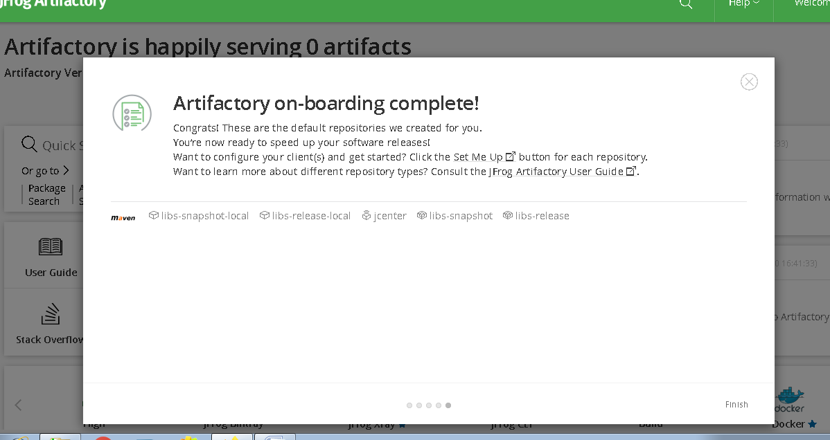

Then click on finish

Now we will be building our project and will be storing our artifactory over here.

**Intergrating Artifactory with Jenkins**

For that first login to Jenkins server on port 8080

Now we will be installing artifactory plugin as follows

click on manage Jenkins

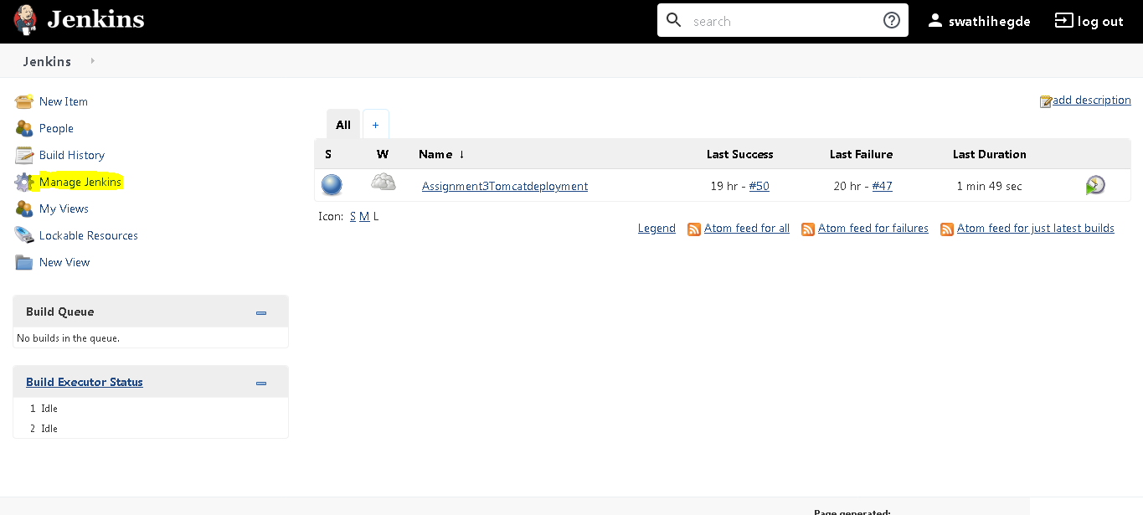

Then Manage plugins

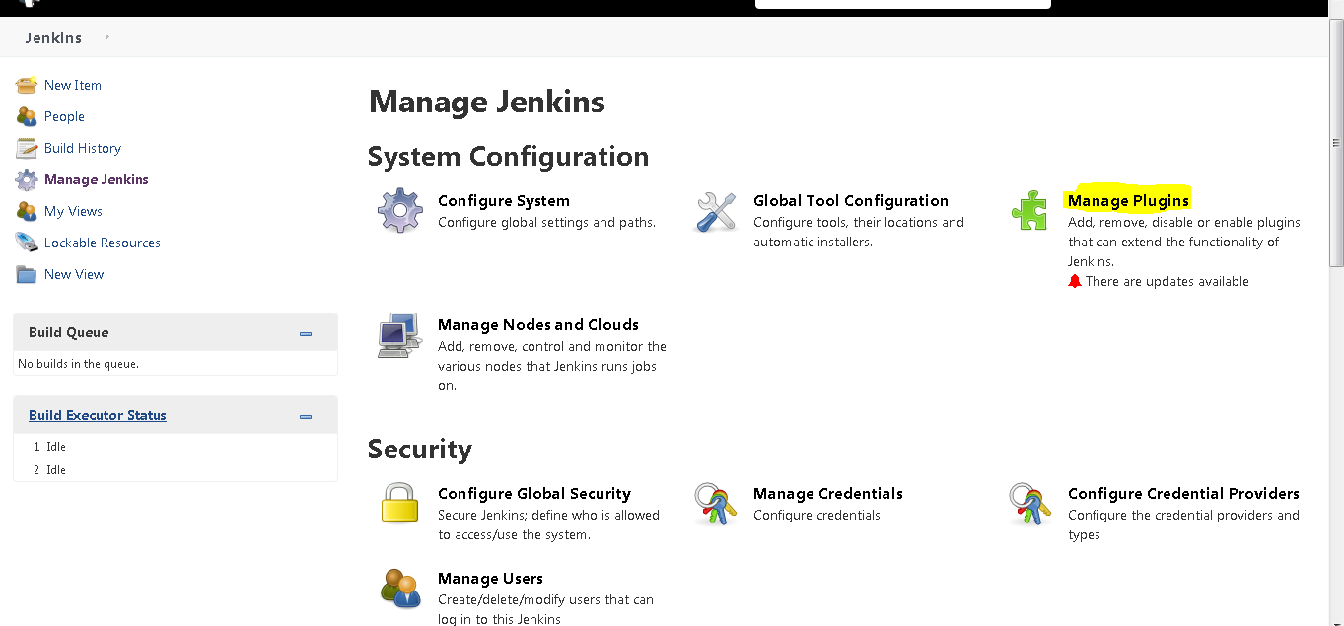

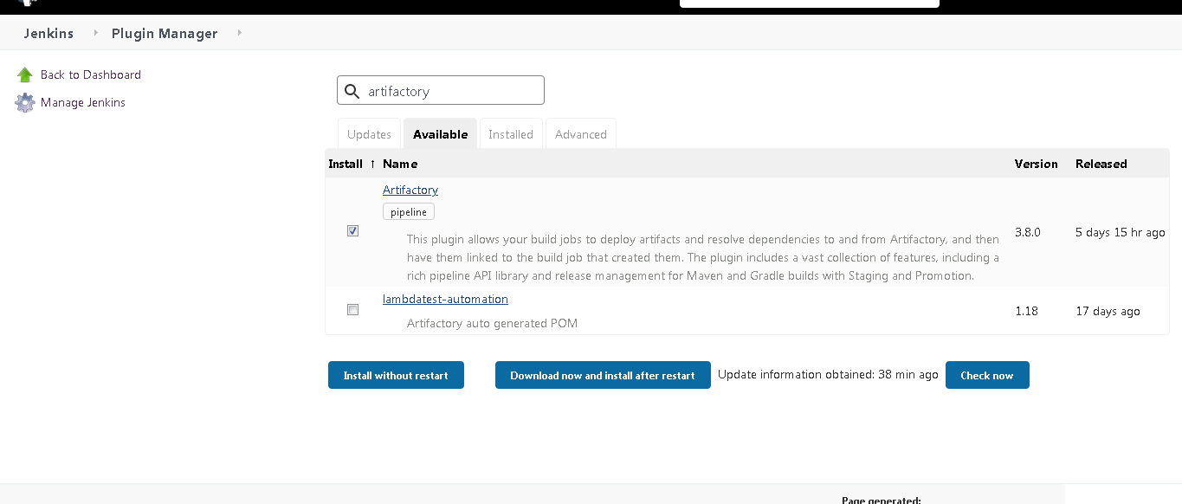

Then go to available tab and search artifactory ,select artifactory and Install without restart.

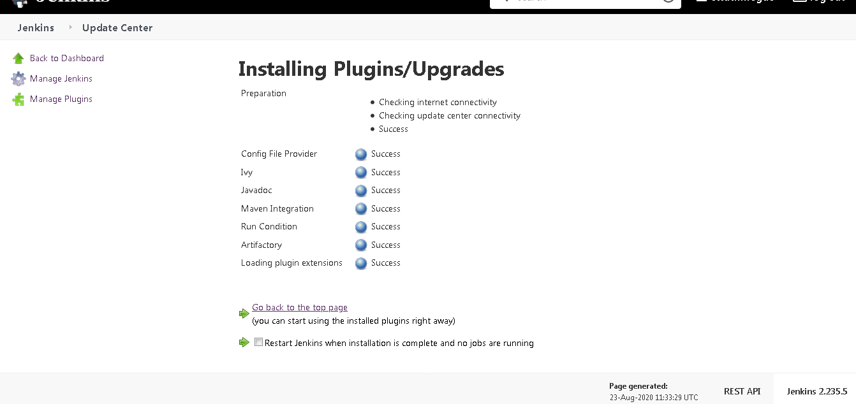

We could see the plugins are installed successfully.

Now we will go back then manage Jenkins and Configure system and there we will be setting up our artifactory server details

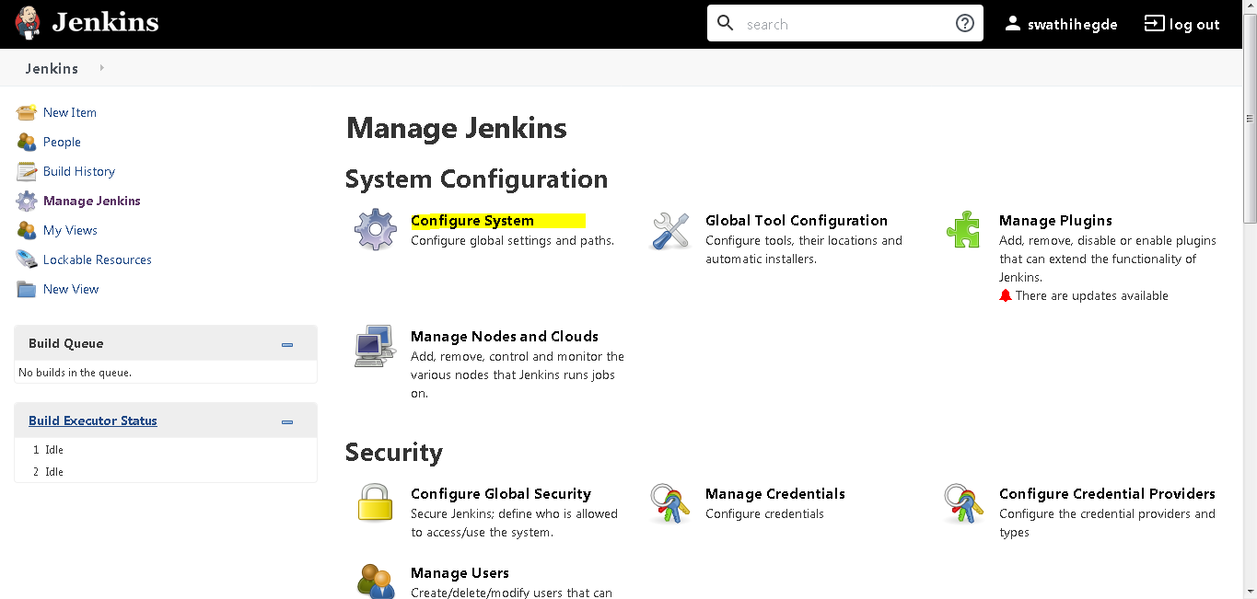

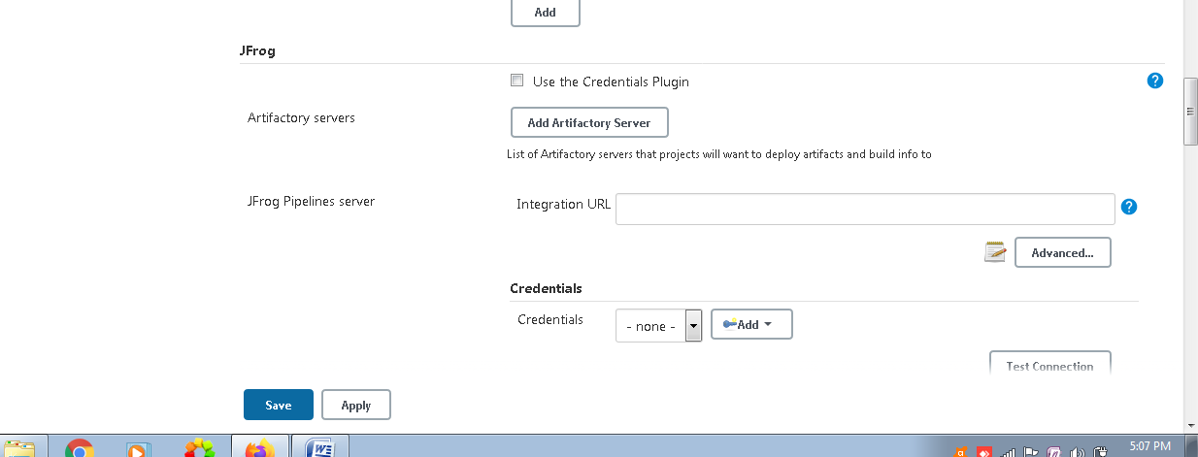

We will be creating 1 new user in jfrog atrifactory server and then we will provide the same credentials in the above,as providing the admin credentials to the Jenkins server is a bad practice.

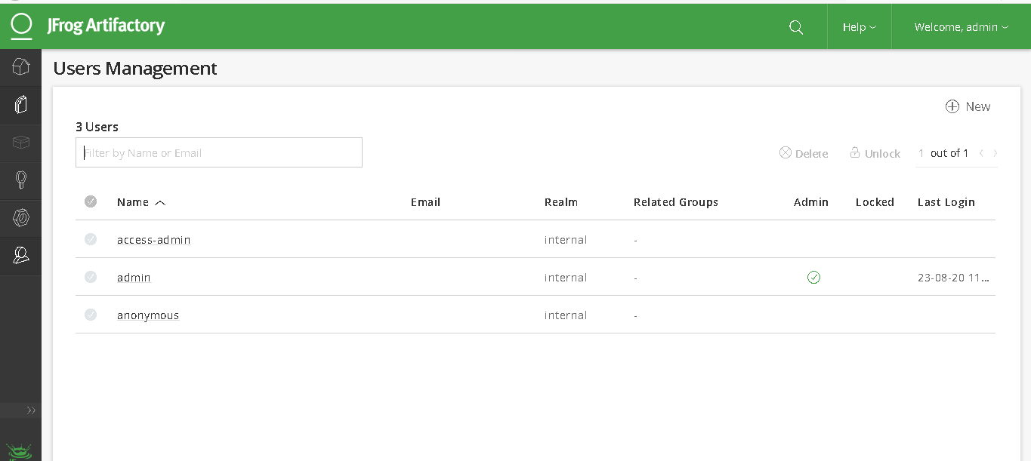

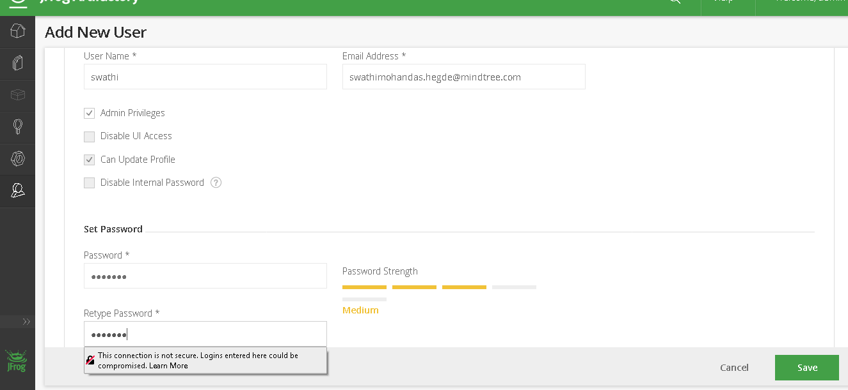

After that provide those credentials in the Jenkins

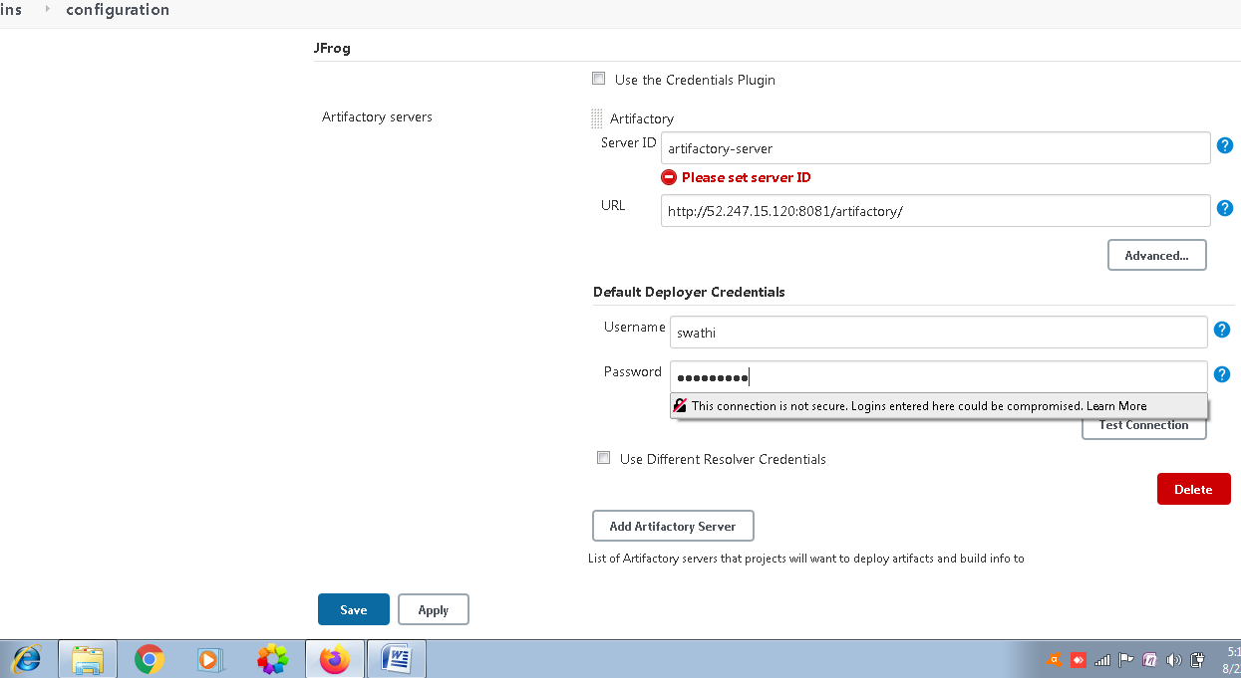

After clicking on test conncetion we get the output as follows

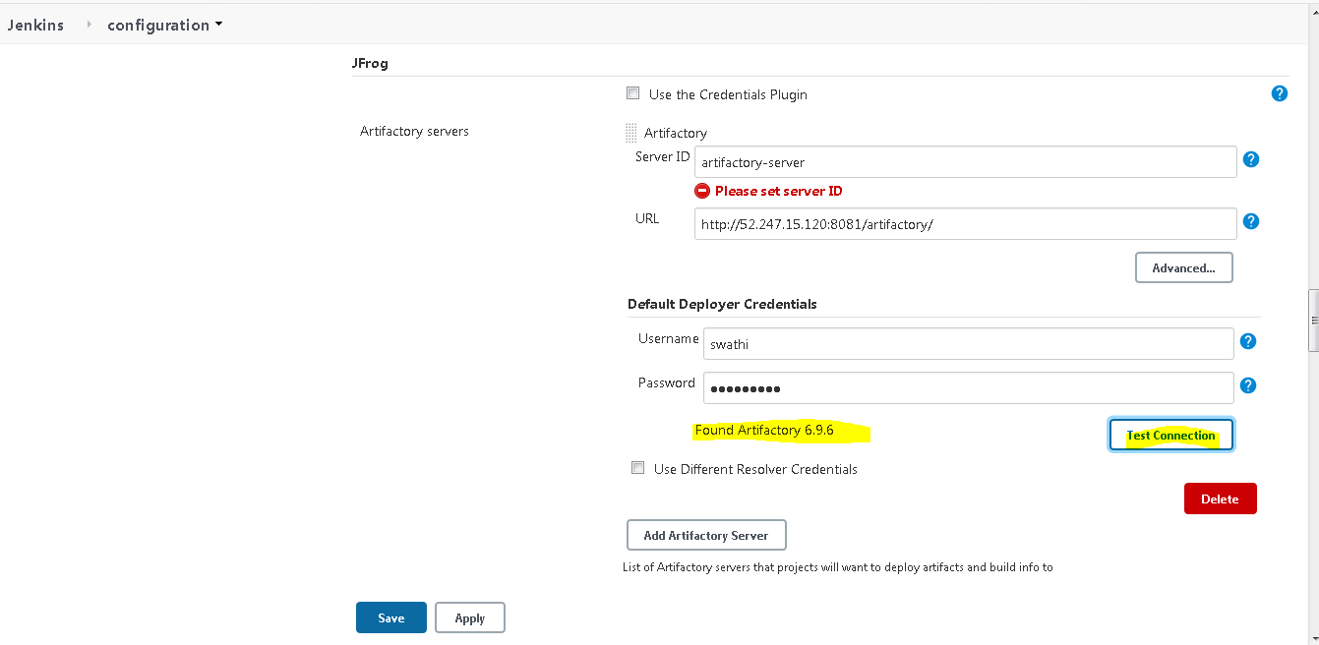

Now we will be creating 1 maven project as follows

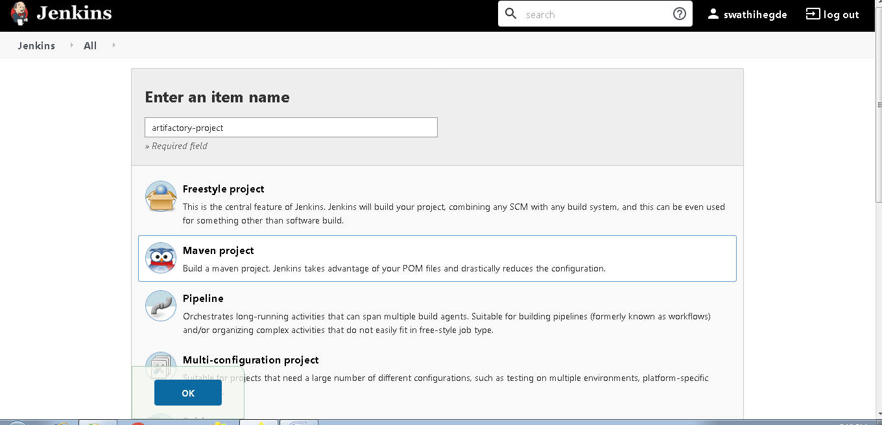

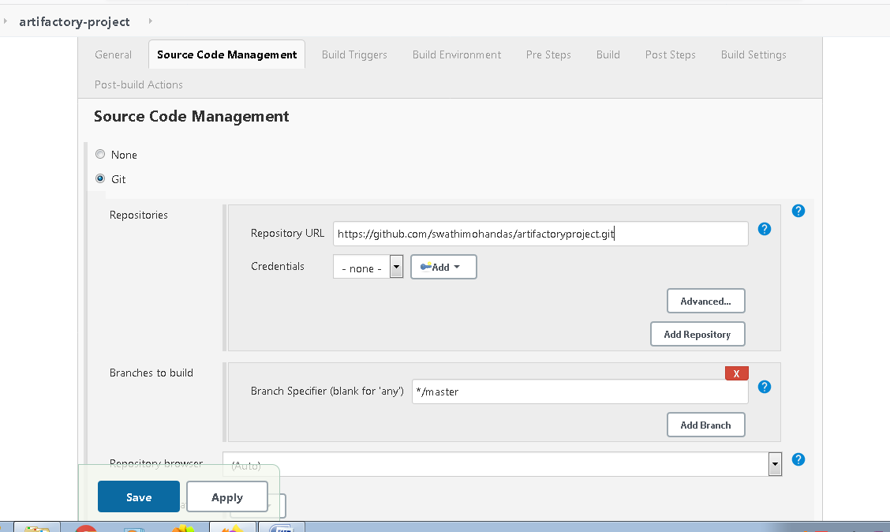

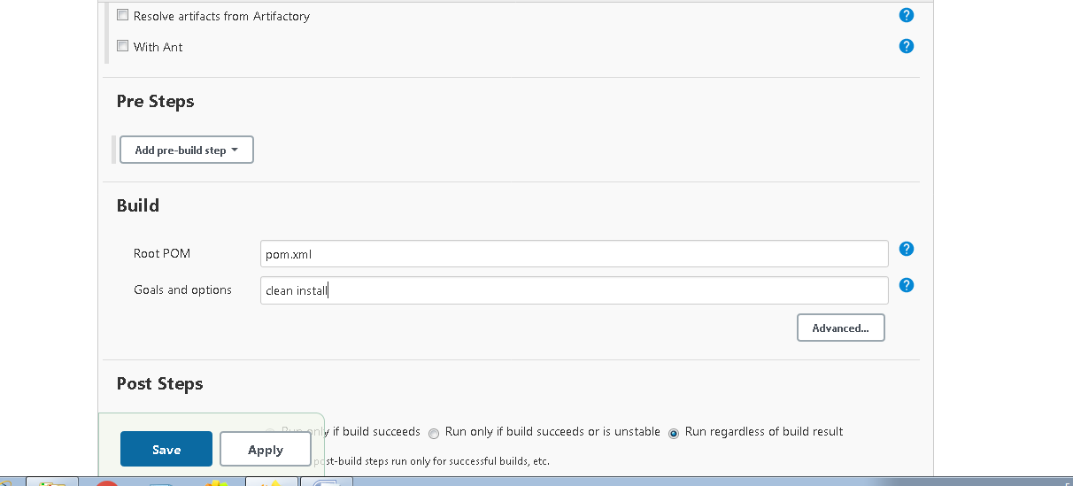

Then post build

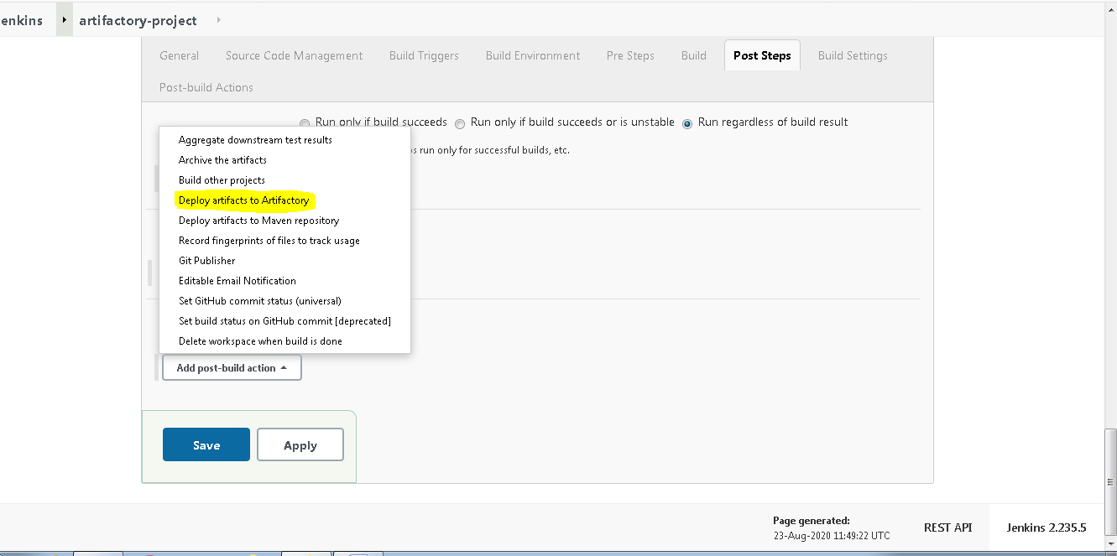

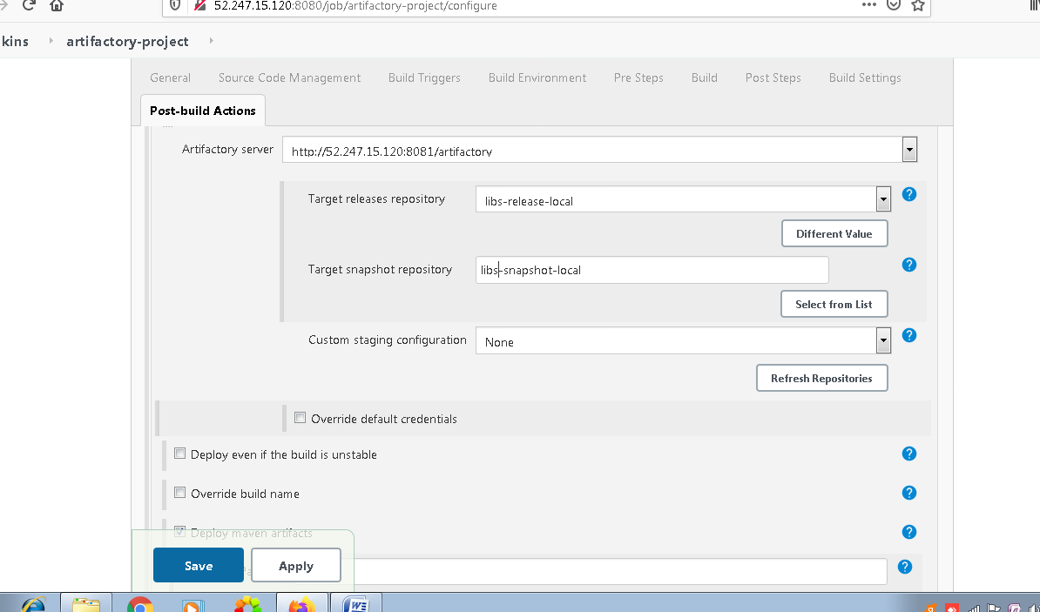

These are by be default setups

Before build you could see that there is no artfactory in the repository in jfrog server.

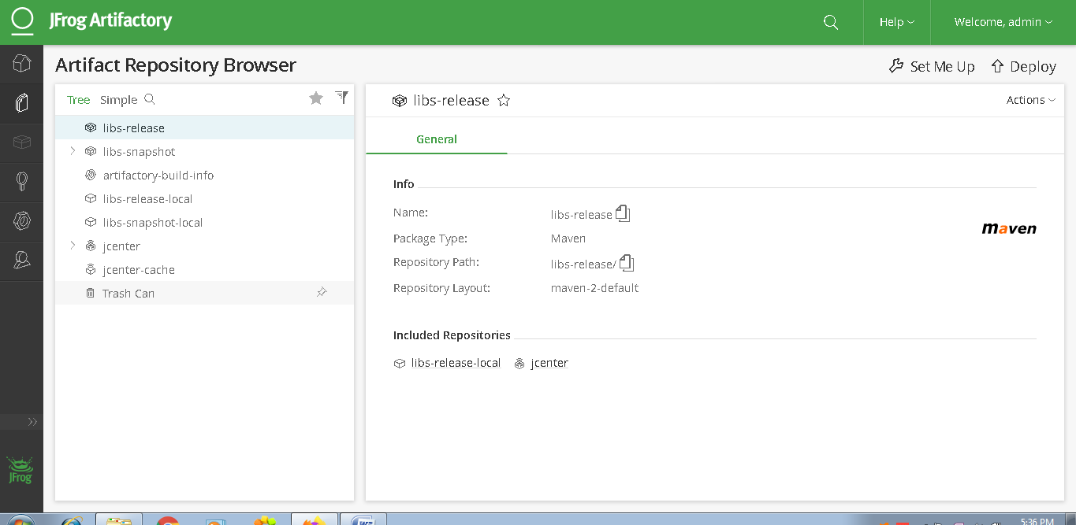

Now we will be building our project as follows

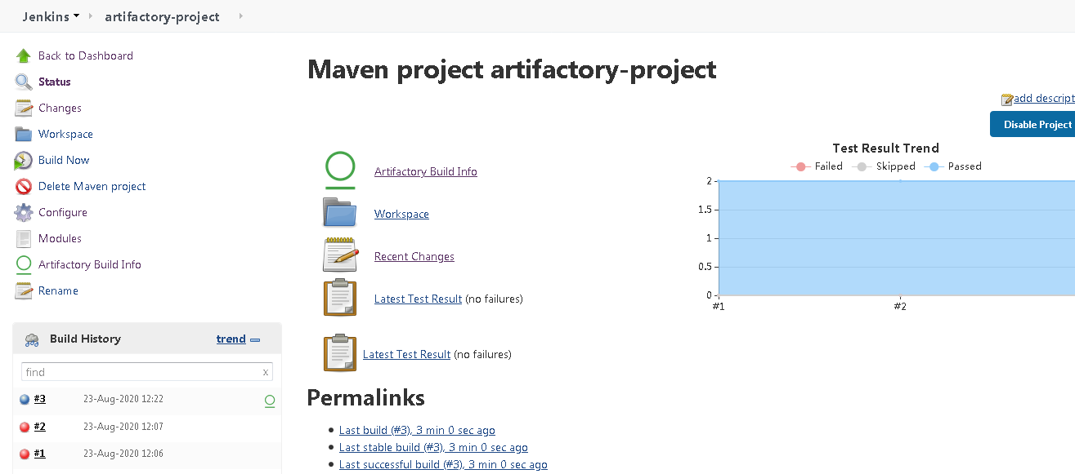

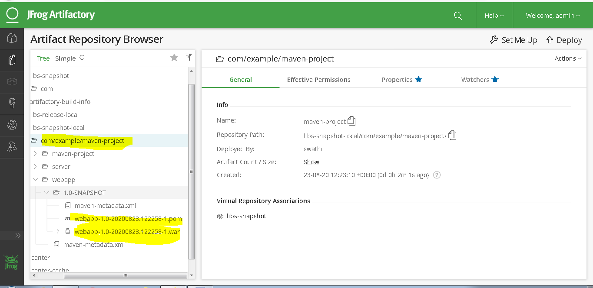

So we could see the snapshots above

Now we will build the project again and check in jfrog server

And we could see 2 versions as follows

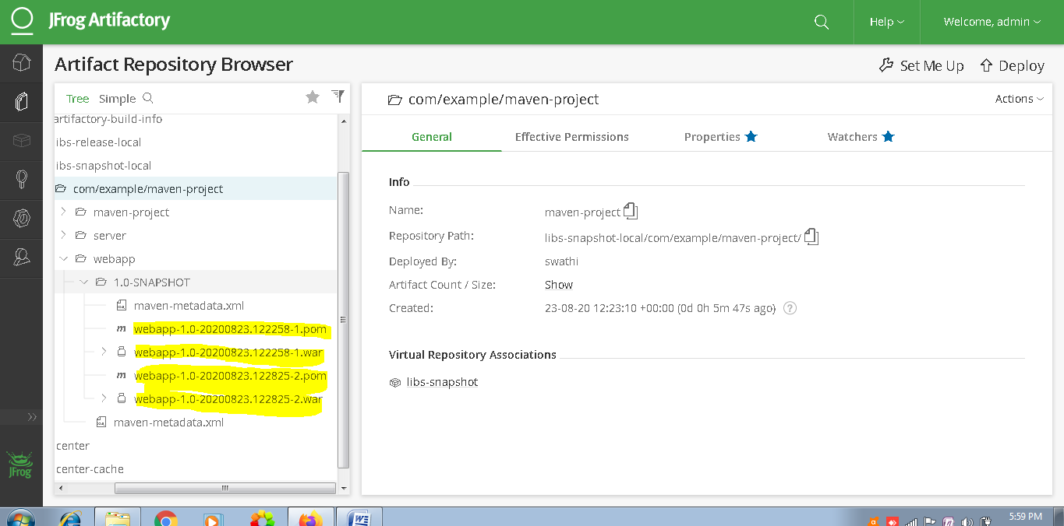

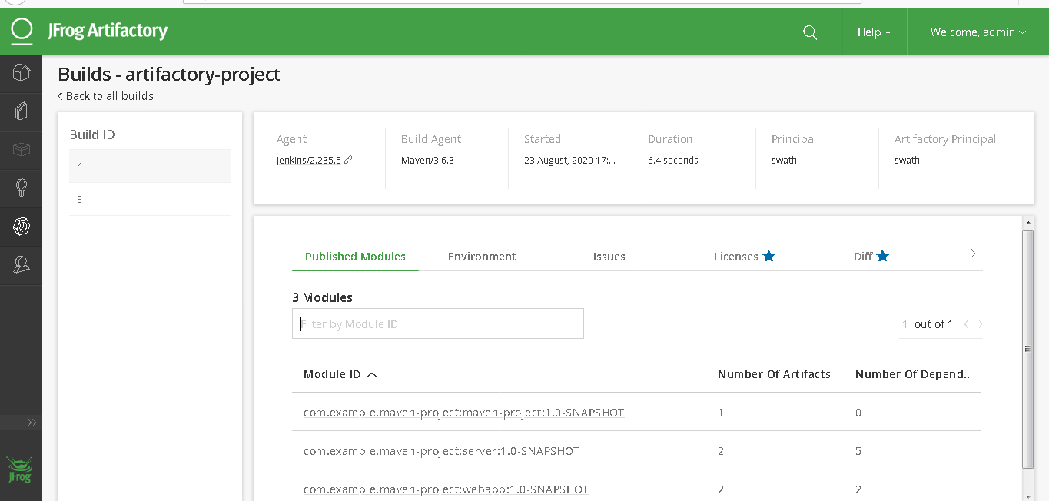

Now we will be setting up sonarqube server in our VM and will be integrating with Jenkins

Sonarqube basically comes with 2 components

Sonarqube Installation

First edit sysctl.conf in /etc folder as follows

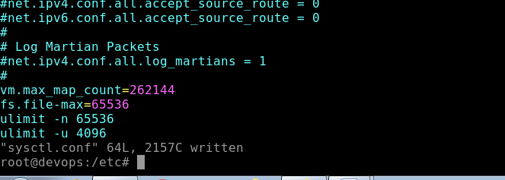

Edit /etc/security/limits.conf

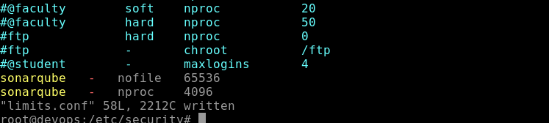

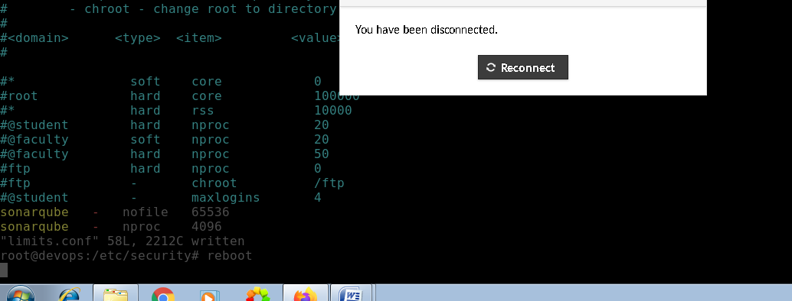

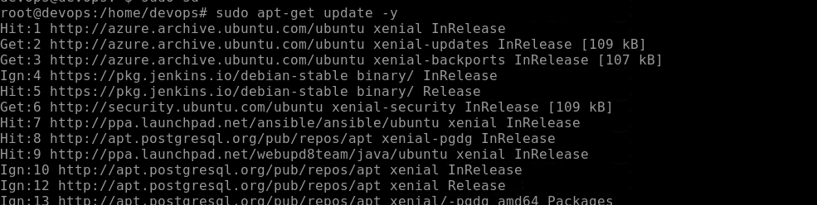

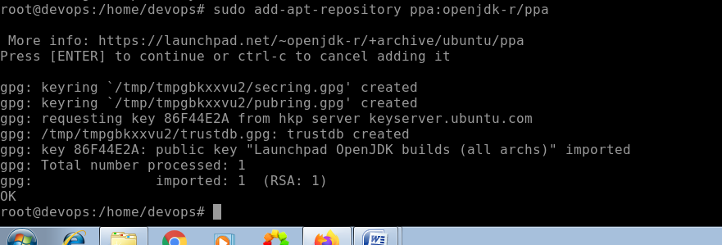

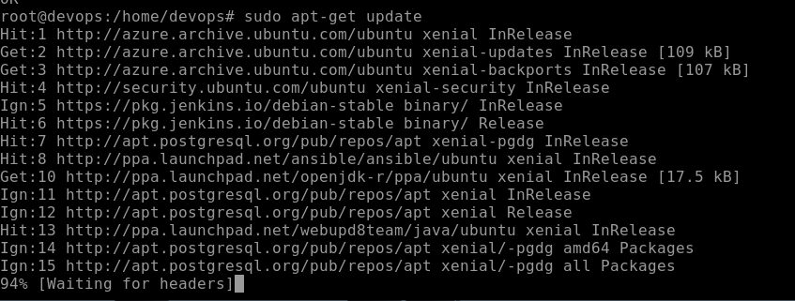

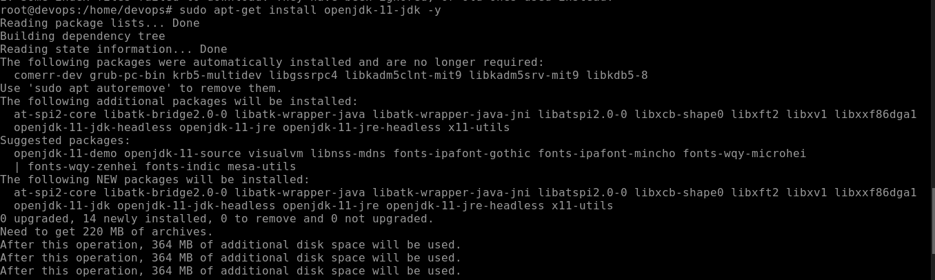

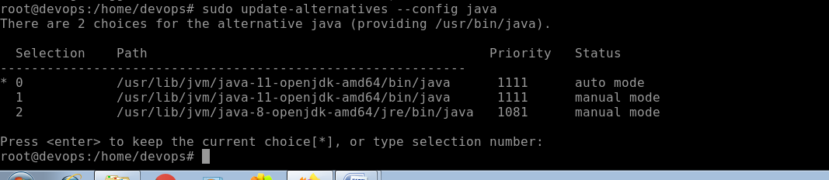

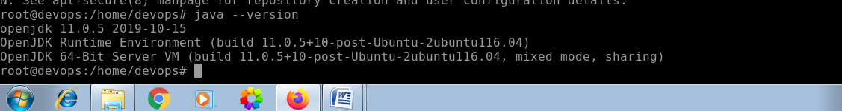

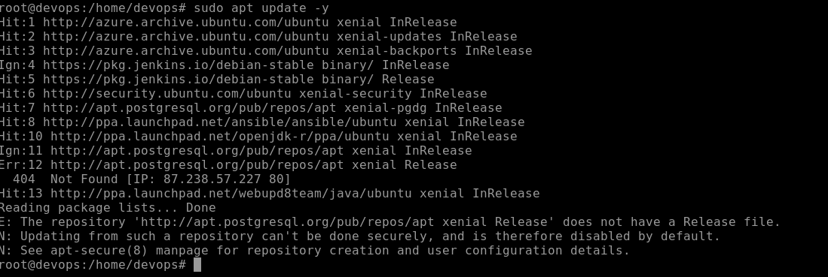

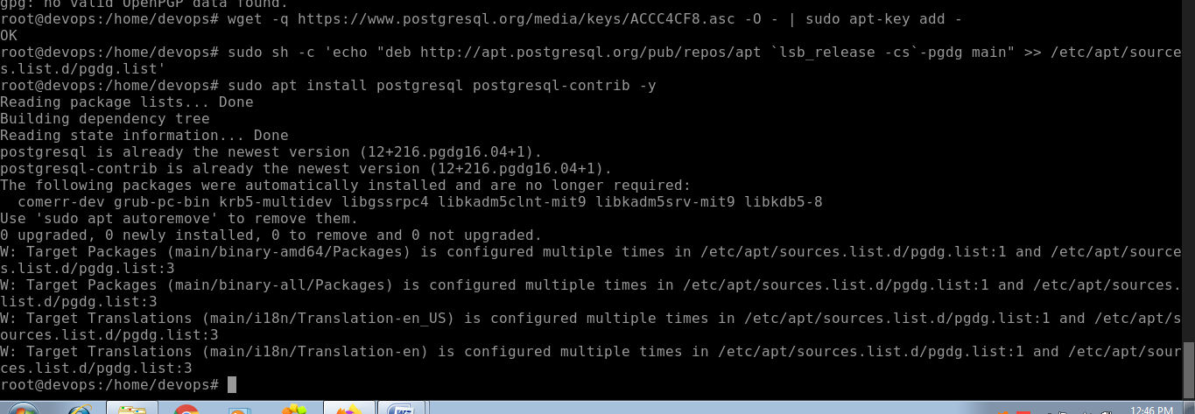

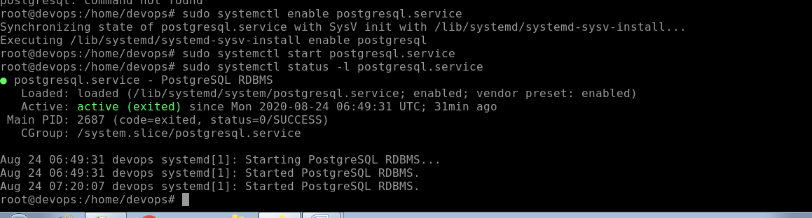

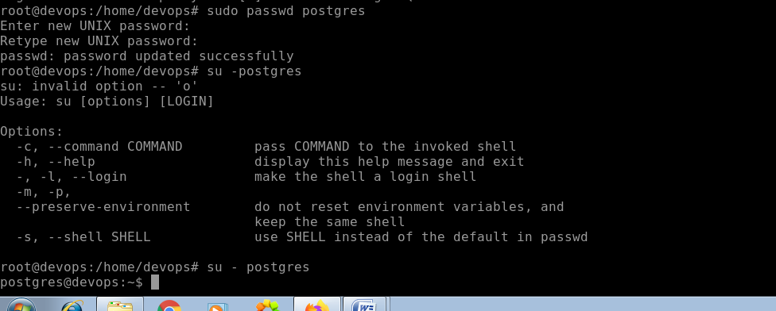

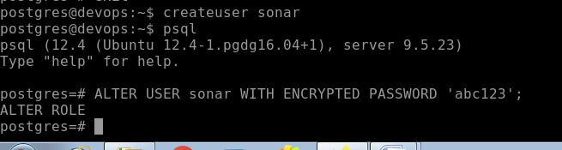

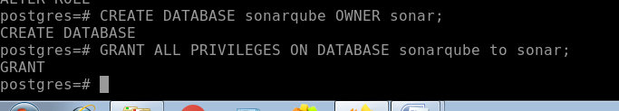

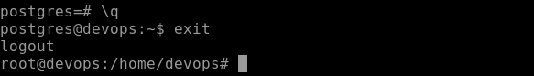

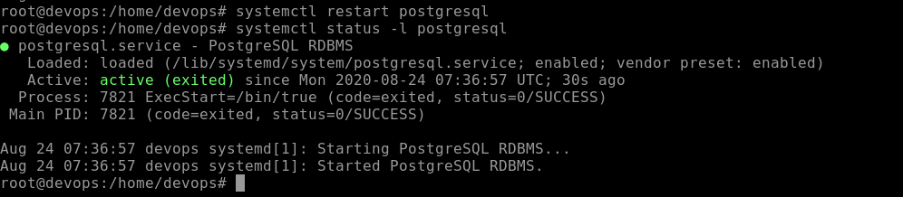

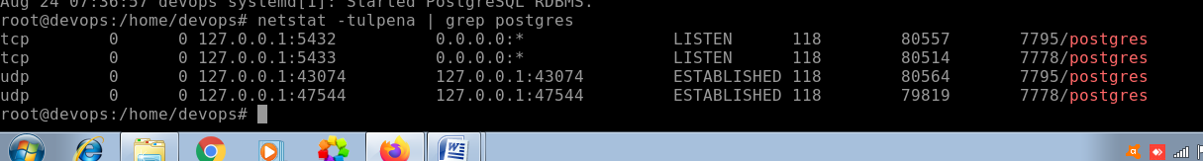

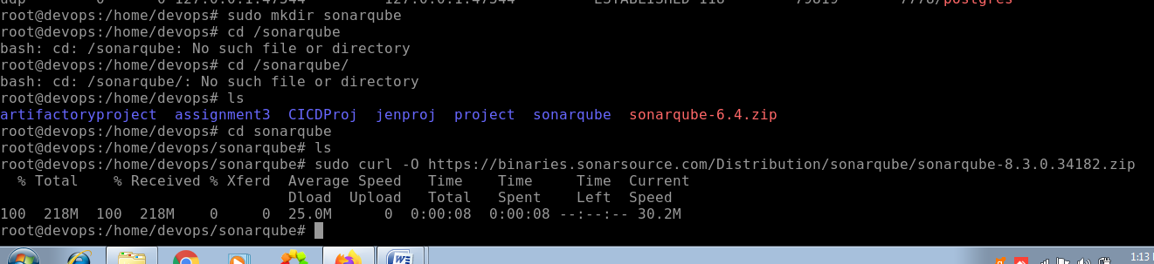

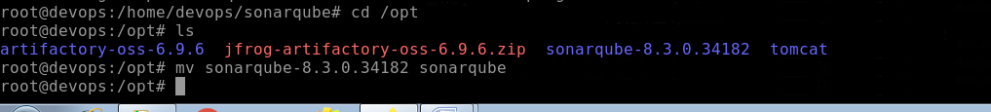

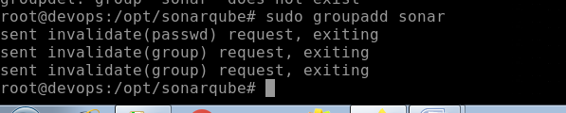

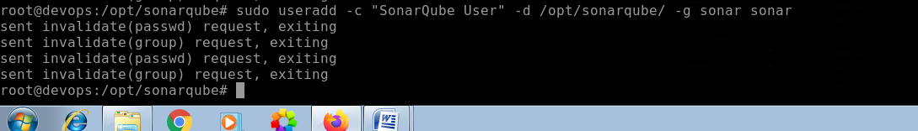

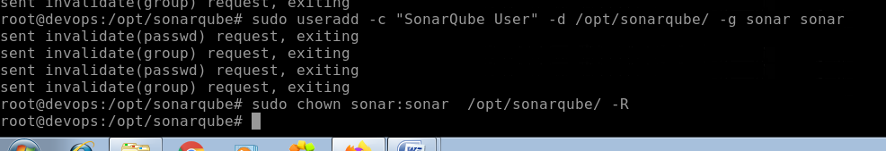

For sonar configuration,we have uncommented few things in sonar.properties file inside /opt/sonarqube/conf/ directory

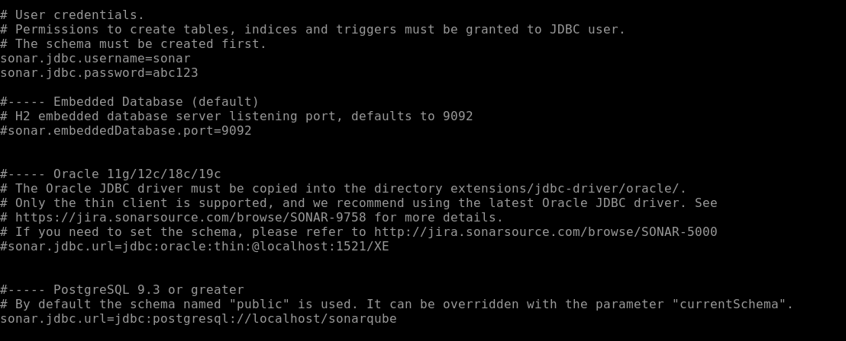

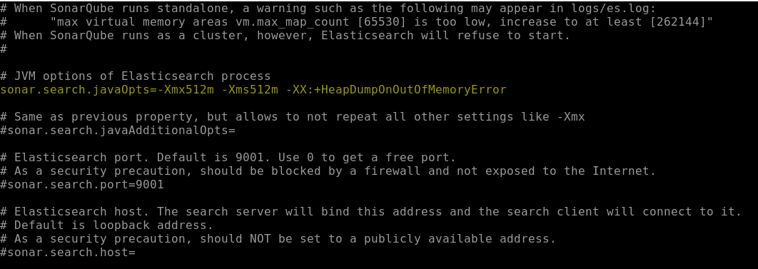

Then /etc/system/system

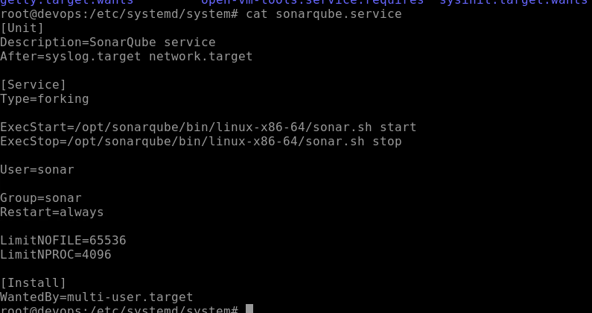

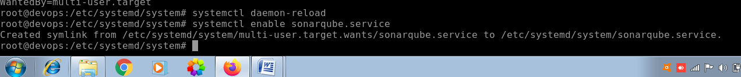

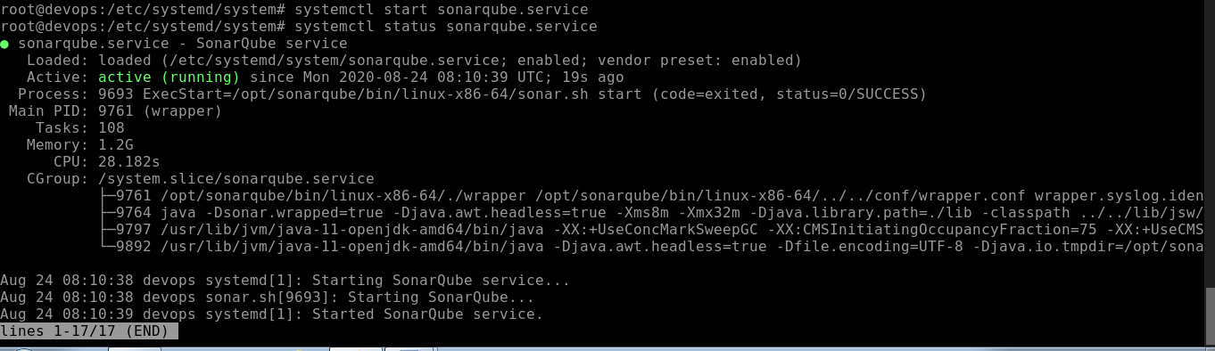



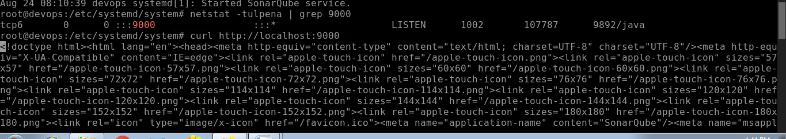

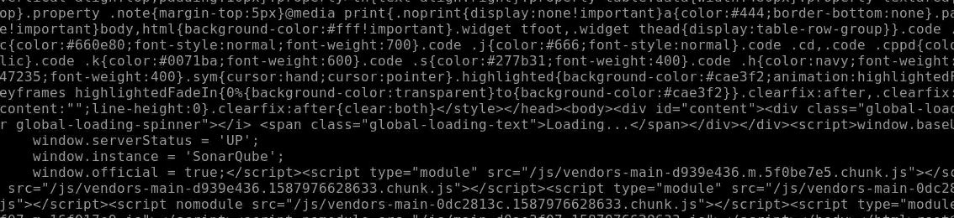

We could see Instance is running

To make the sonarqube accessible to outside world we will do the following

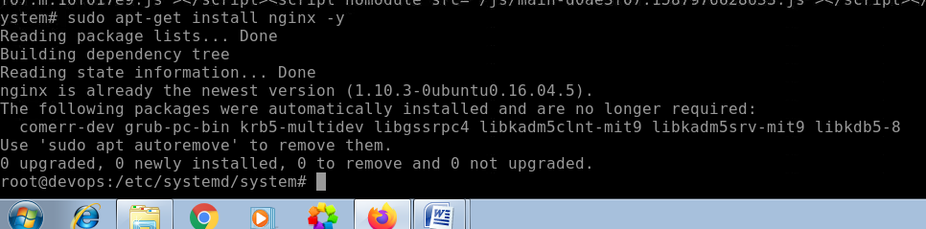

Check if these are enabled in /etc/nginx/nginx.conf

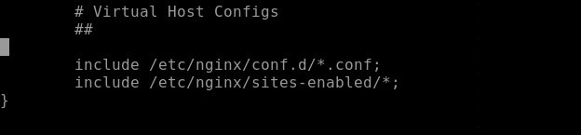

Now we will be creating virtual host

We will be creating a file under sites-enabled directory

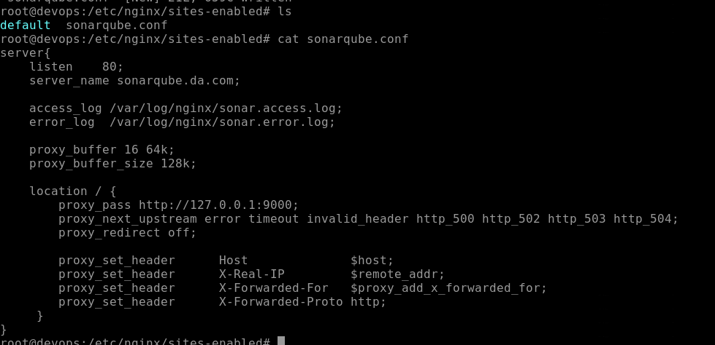

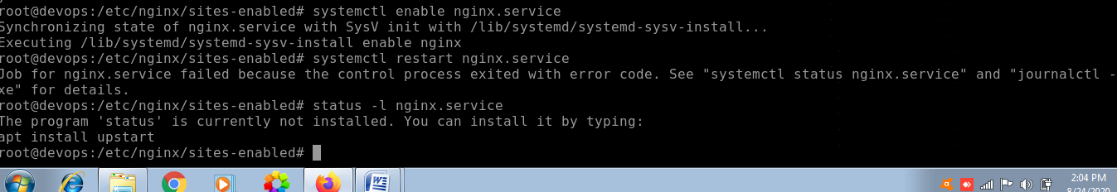

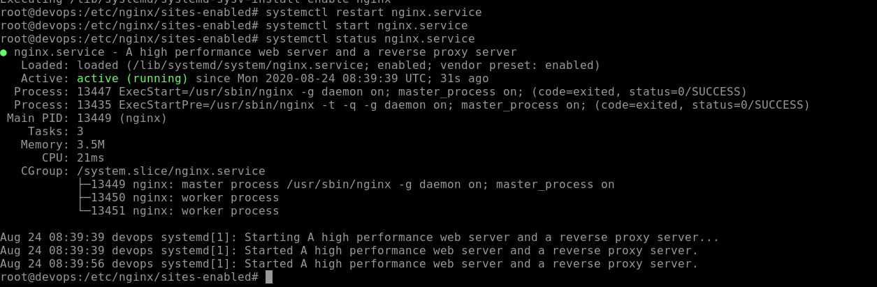

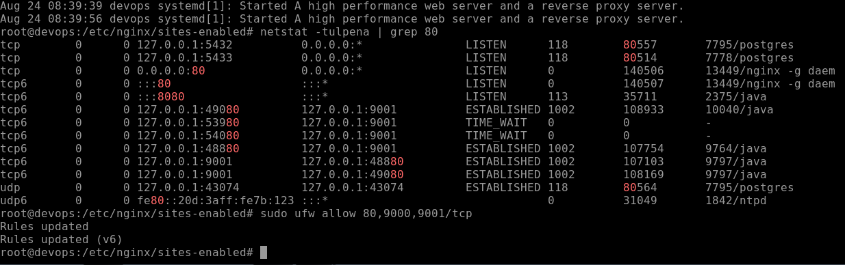

Now go to browser and check on port 9000

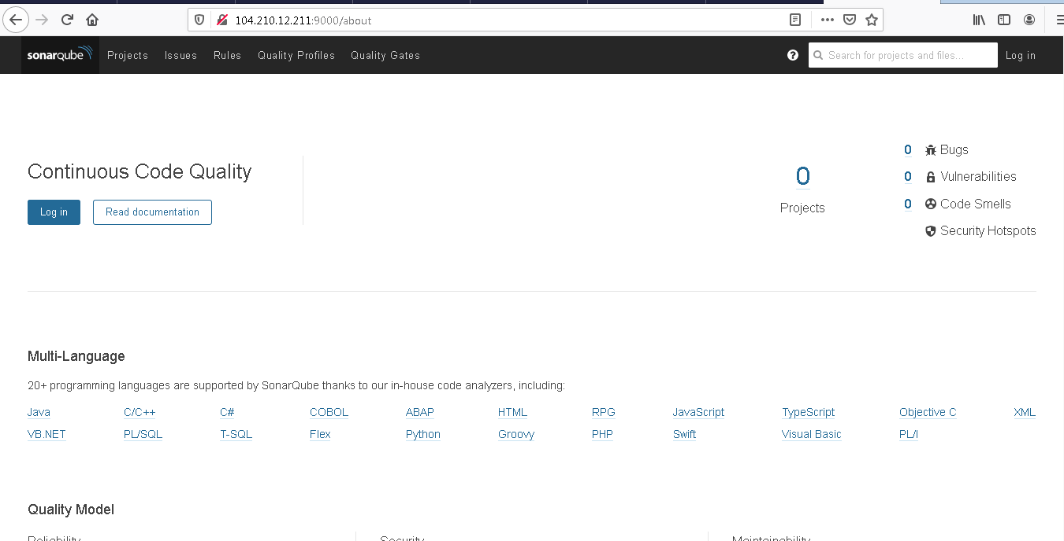

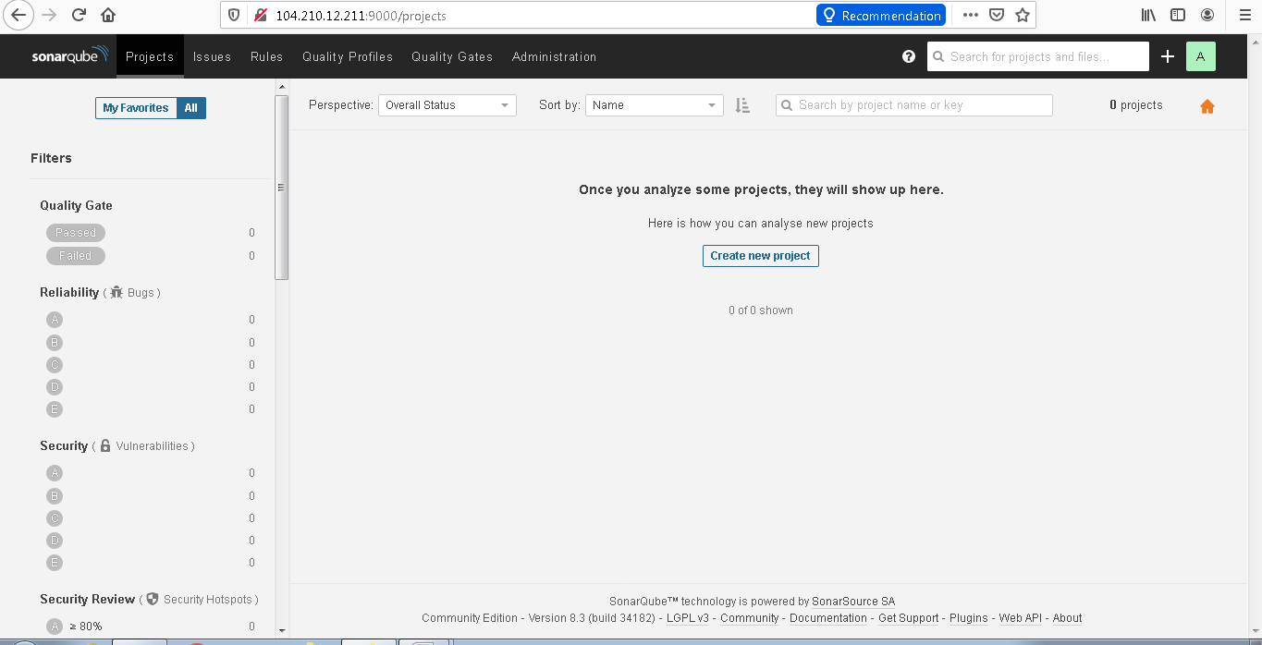

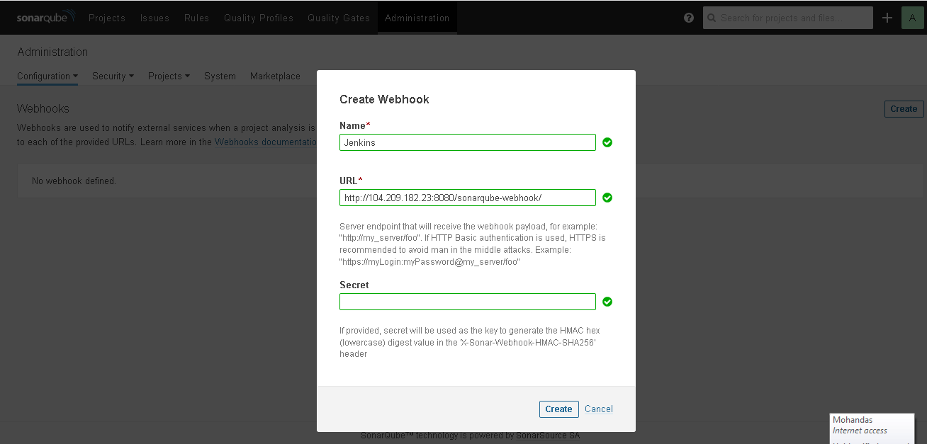

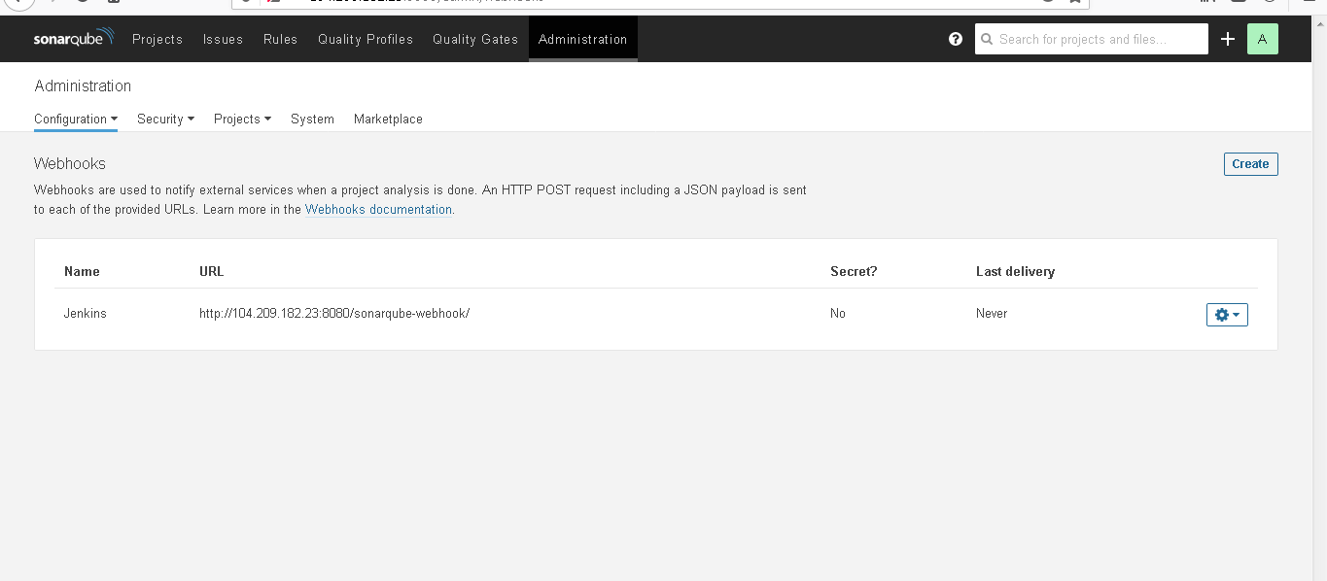

Now we will be integrating sonarqube with Jenkins

For that we need to install sonarqube plugins in Jenkins as follows

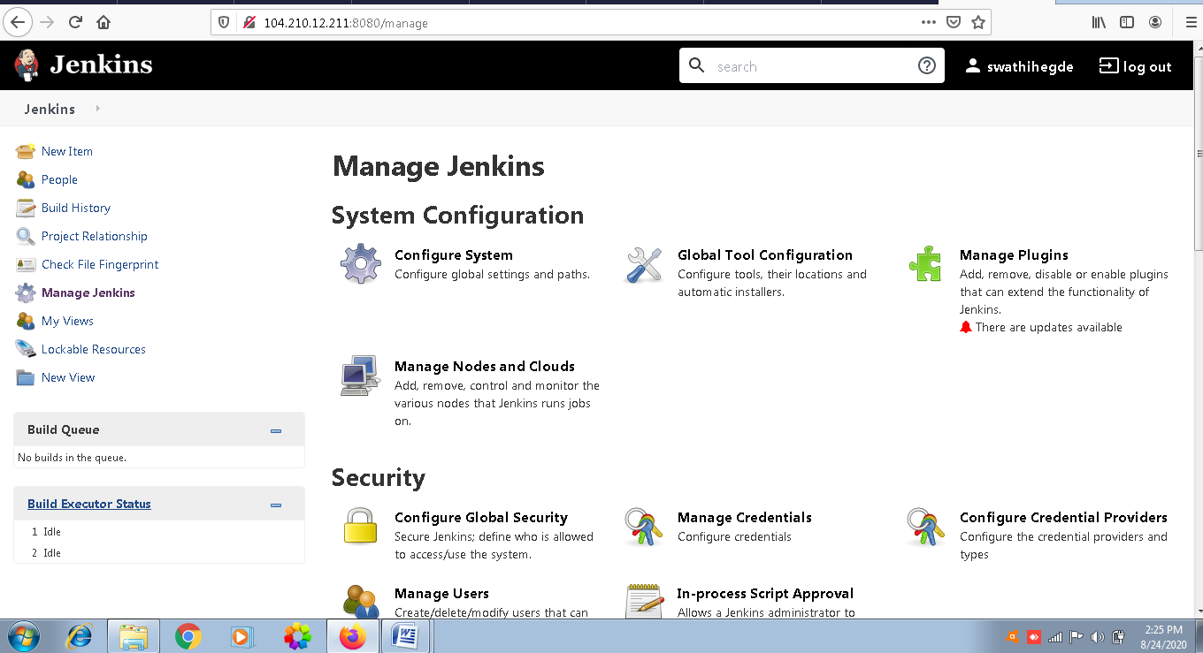

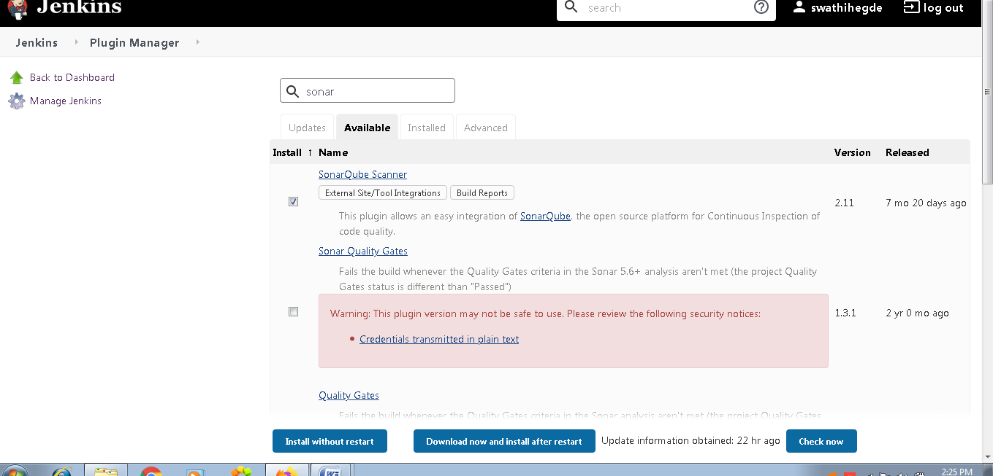

Click on install without restart

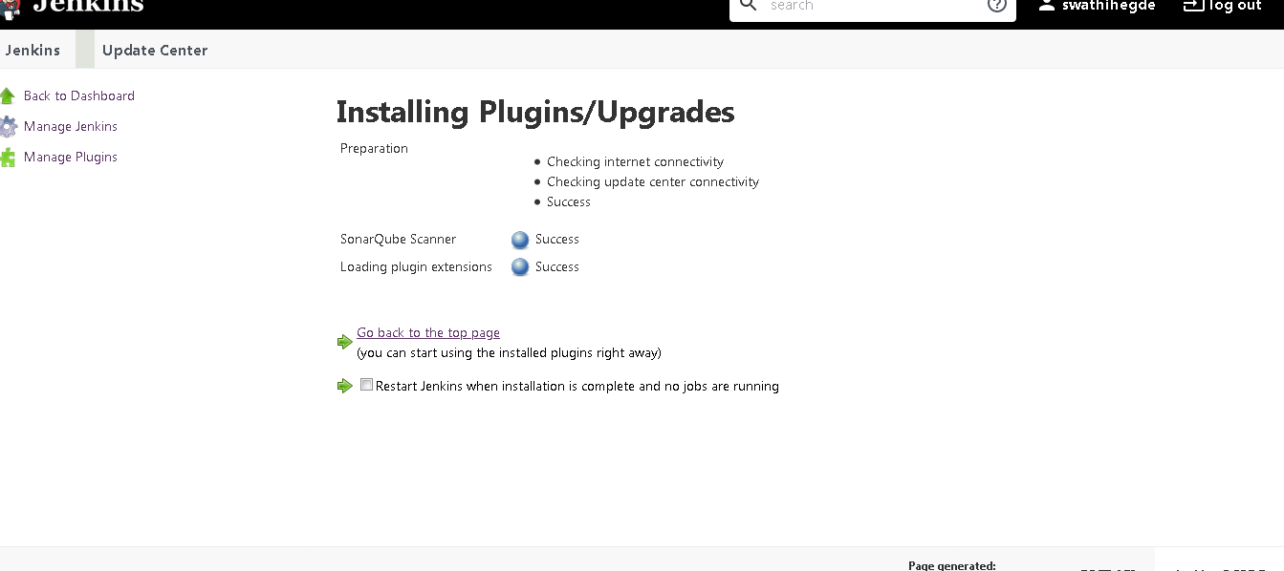

Then go to sonarqube site

Then click on administration tab

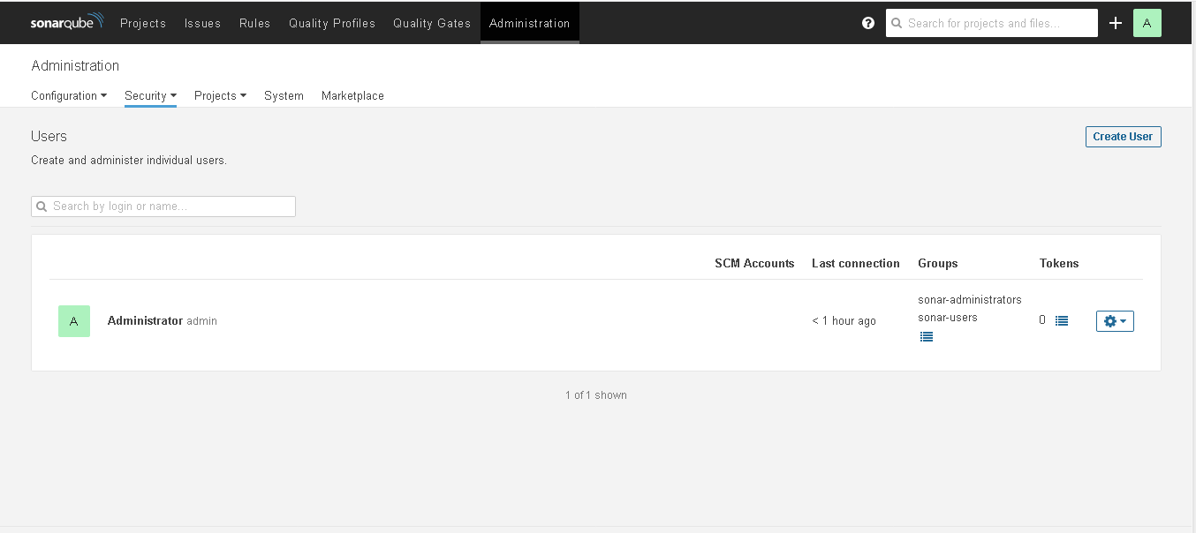

Now we will be creating a token

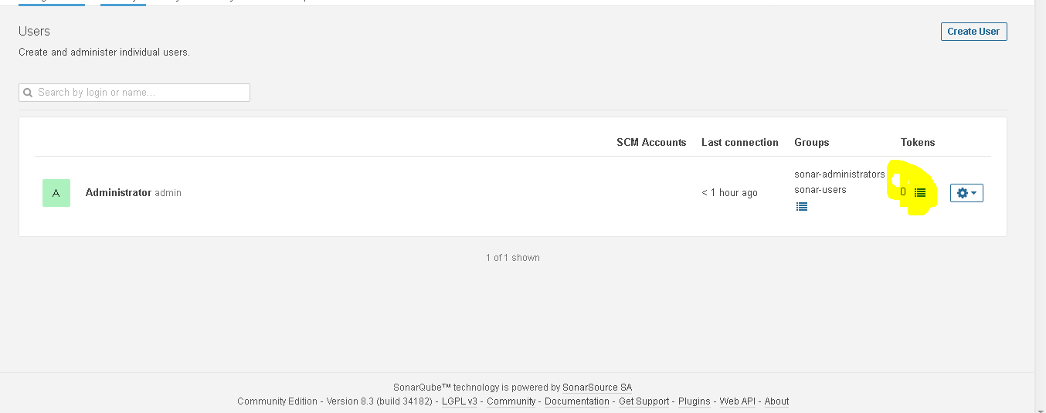

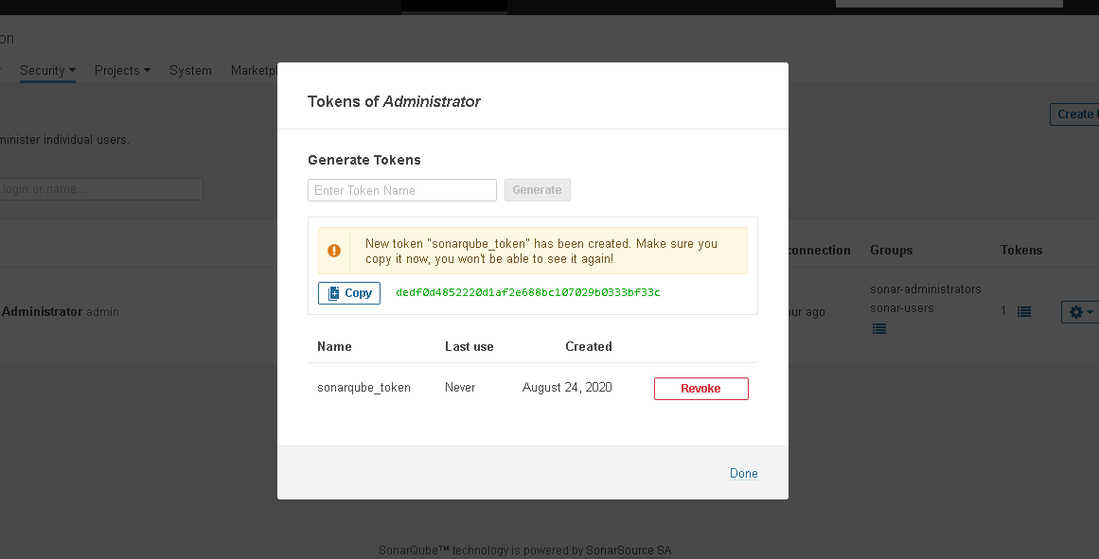

Now we could see the token generated

dedf0d4852220d1af2e688bc107029b0333bf33c

Then copy that token and then go to Jenkins page

Manage Jenkins 🡪 Configure Jenkins

Go to sonarqube section

Then add sonarqube

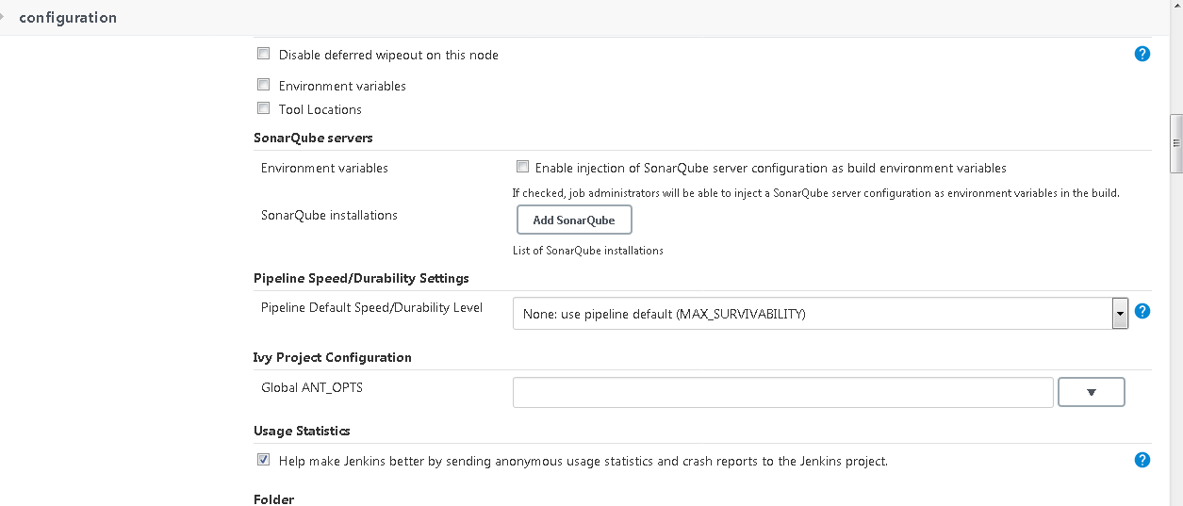

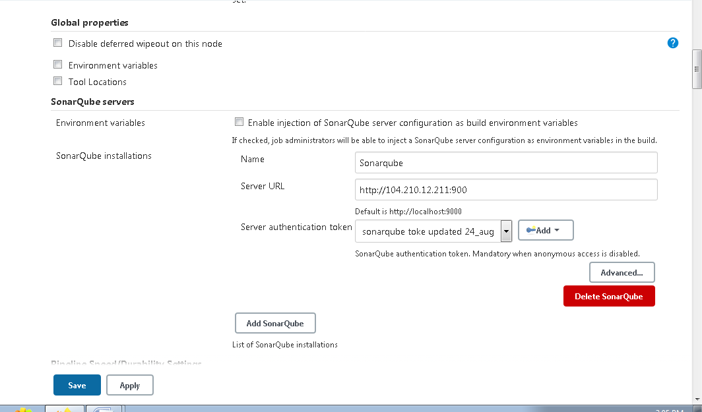

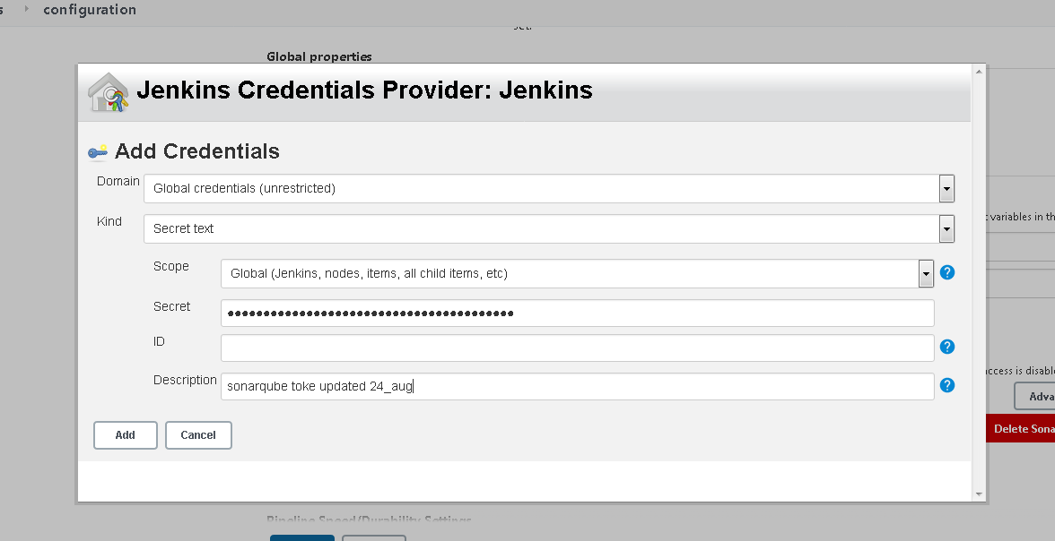

**Now we will be installing sonar-scanner as well in our linux system**

**After installation of sonar-scanner in /opt/sonar-scanner directory**

**Go to conf directory and make following changes**

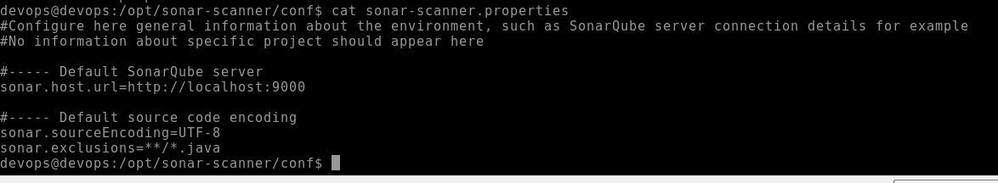

**Also configure the sonarqube and sconar scanner in Jenkins as follows**

**Manage Jenkins 🡪 global tool configuration**

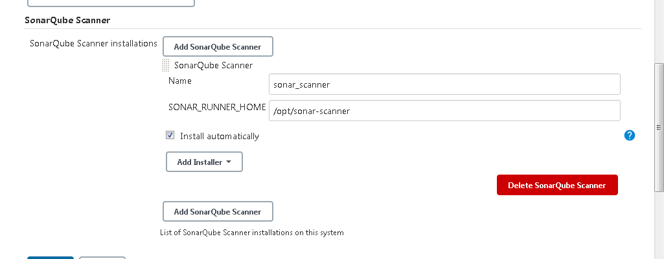

**Note :Here we should give the path of the sonar_scanner**

**Now we will be creating 1 pipeline project**

**We will be installing jacoco plugin as well as follows**

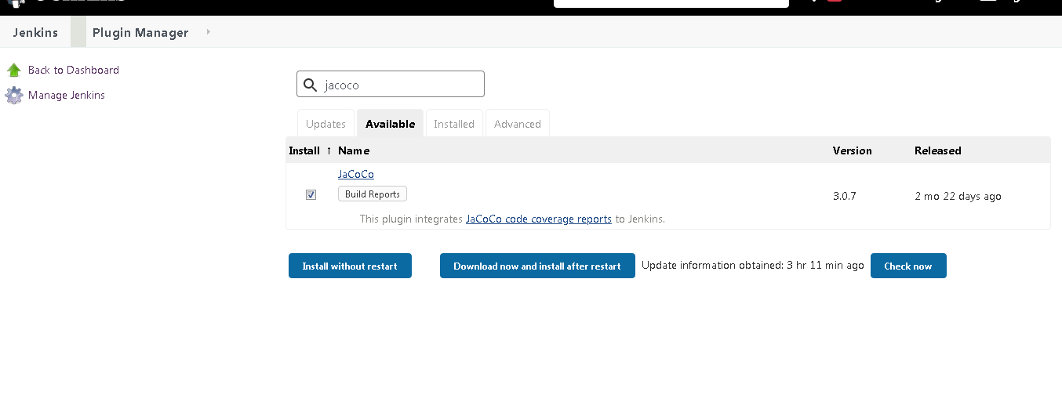

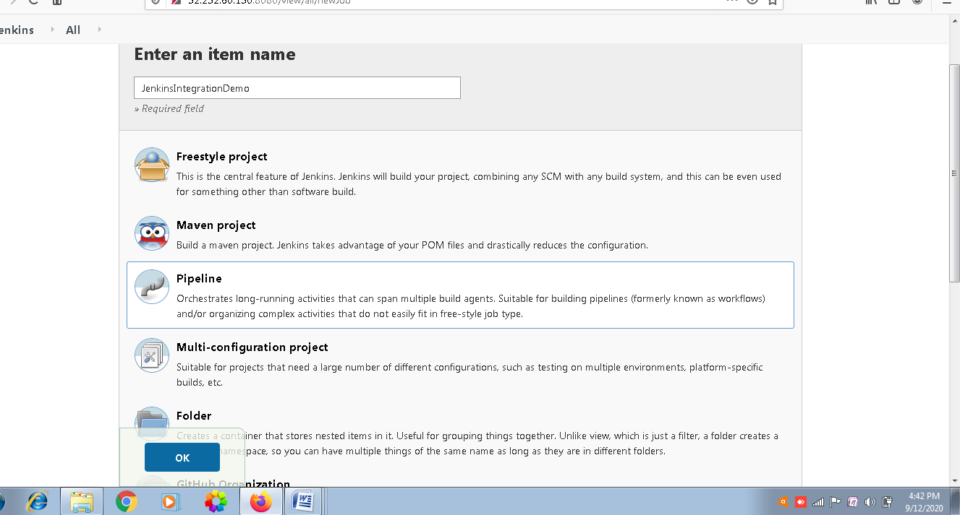

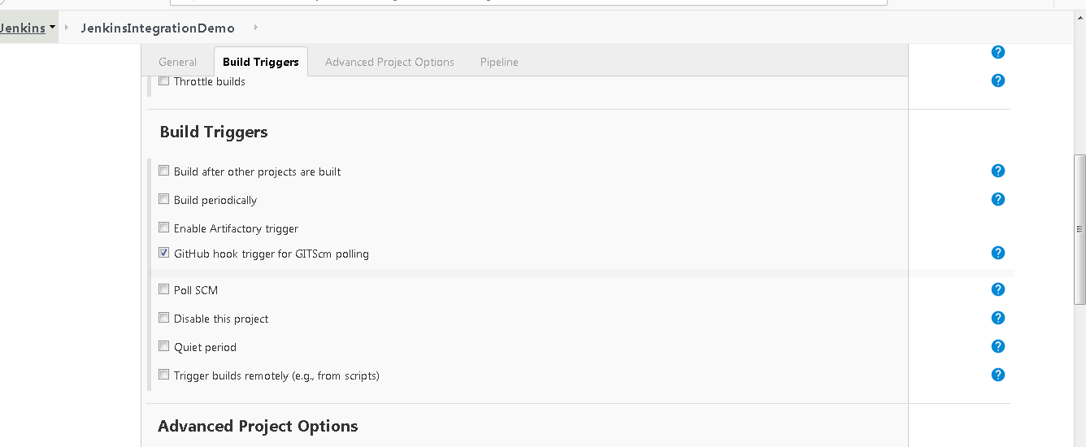

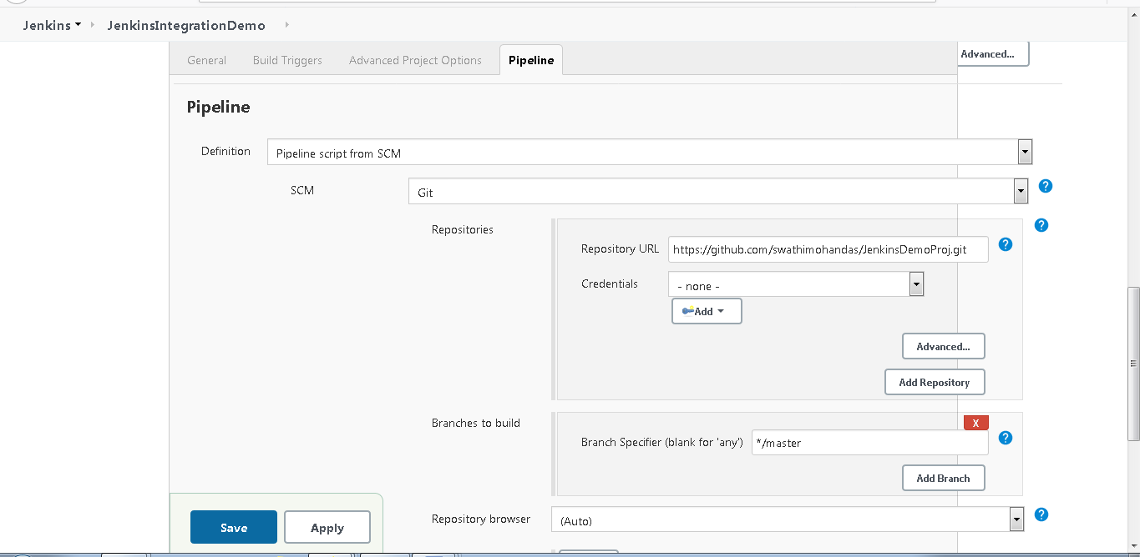

**In the pipeline script we will be writing following stages**

**1.Checkout**

**2.Build (mvn clean compile)**

**3.Test(mvn surefire:test)**

**4.Jacoco (Java code coverage0**

**5.Sonar scanning (Sonar gate)**

**6.Package(mvn package –DskipTests)**

**7.** **deploy (mvn clean deploy) to Jfrog artifactory**

**Please find the screenshots of the pipeline script for the same.**

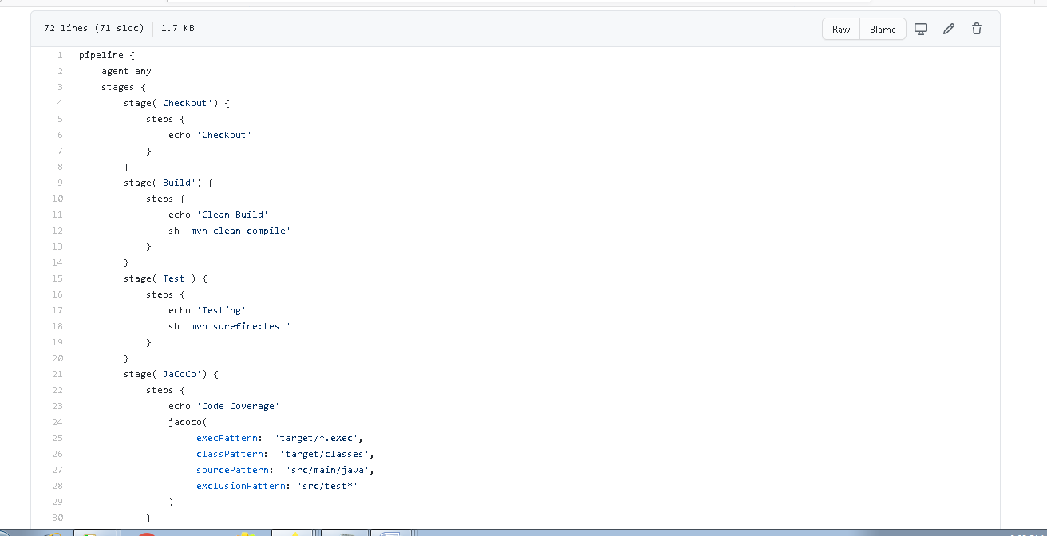

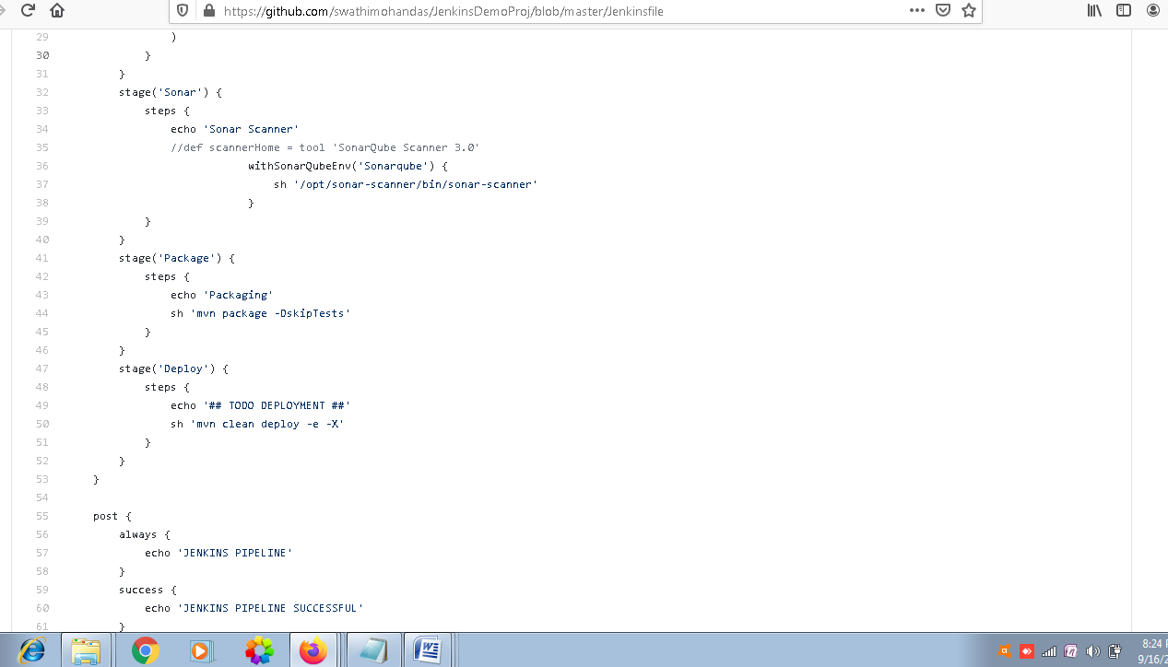

**We will mention all the dependencies in pom.xml file as follows**

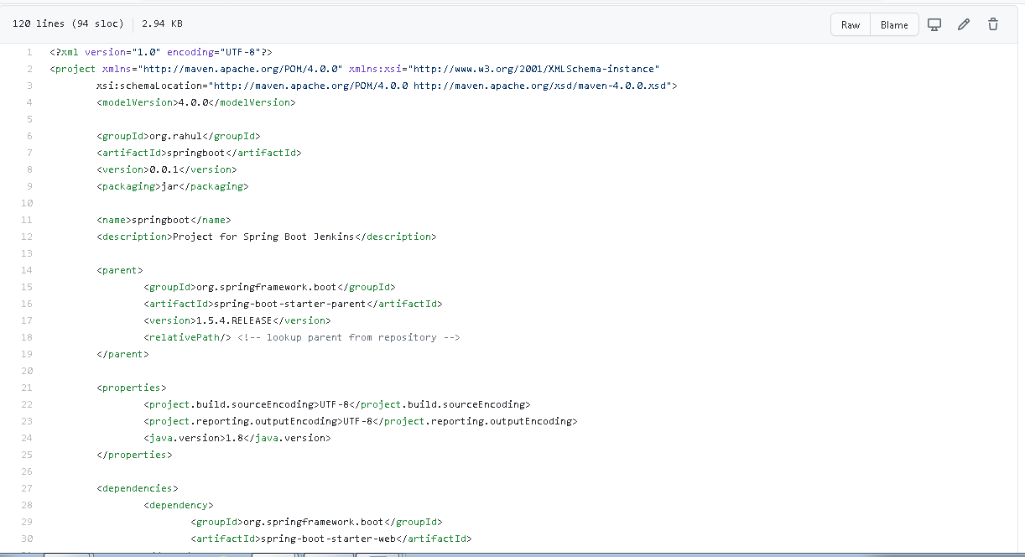

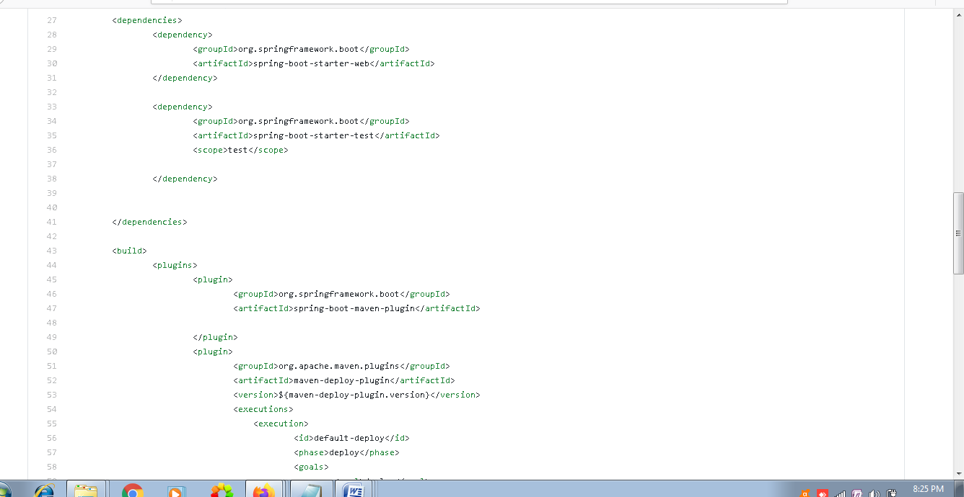

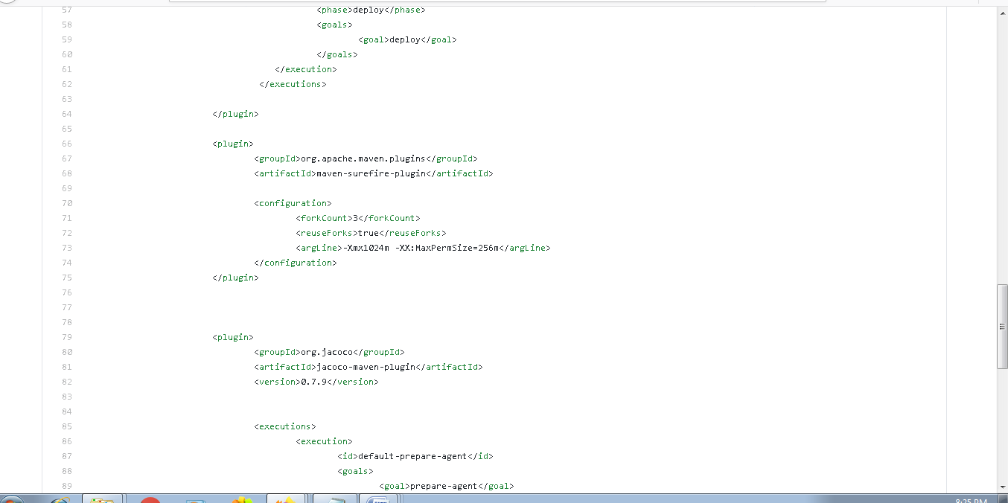

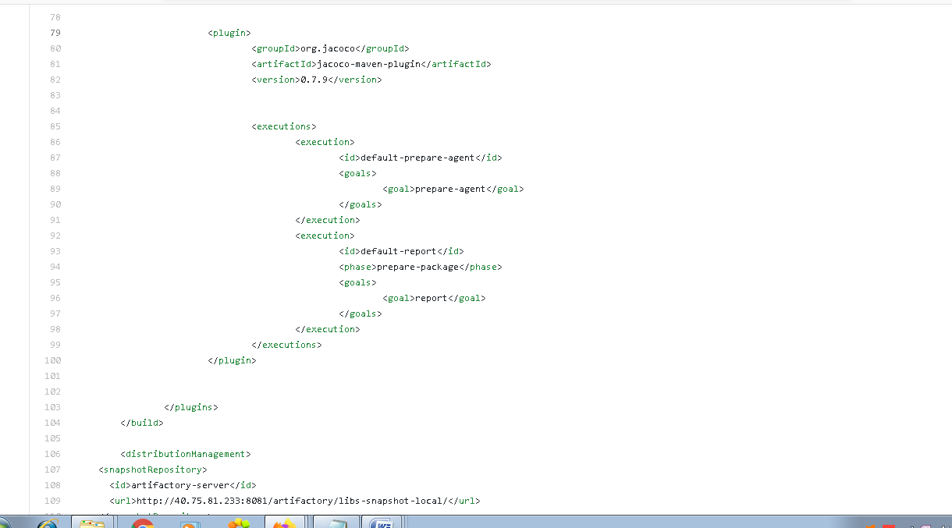

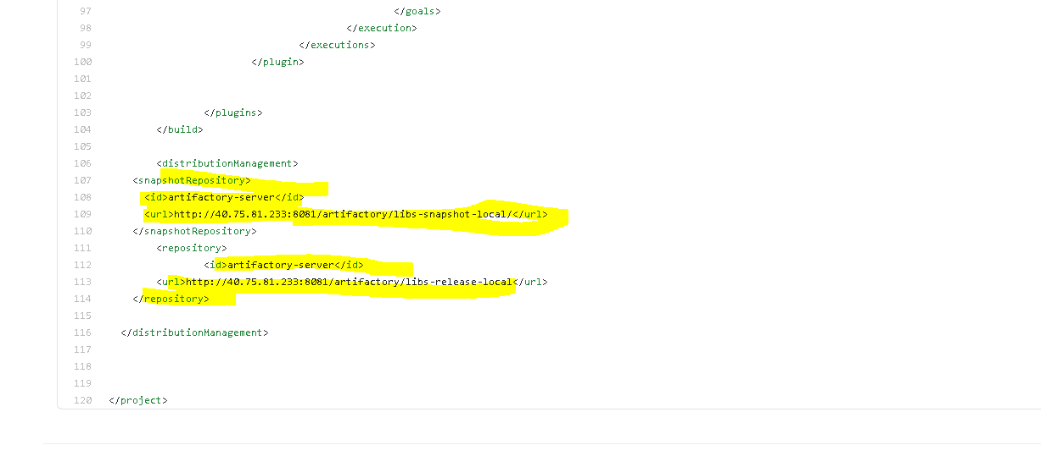

**We will mention the artifactory details as well in the pom.xml file**

**And since we are deploying the artifacts thru pipeline scipt we need to mention the credentials for the artifactory repository in settings.xml file under /etc/maven repository**

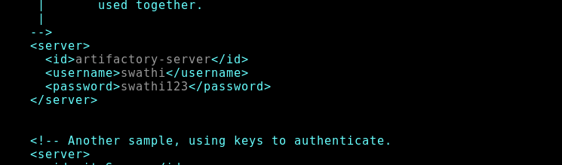

**Please find the pipeline script output**

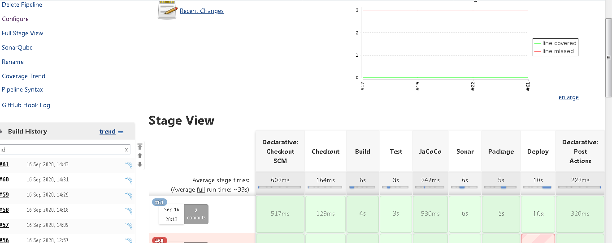

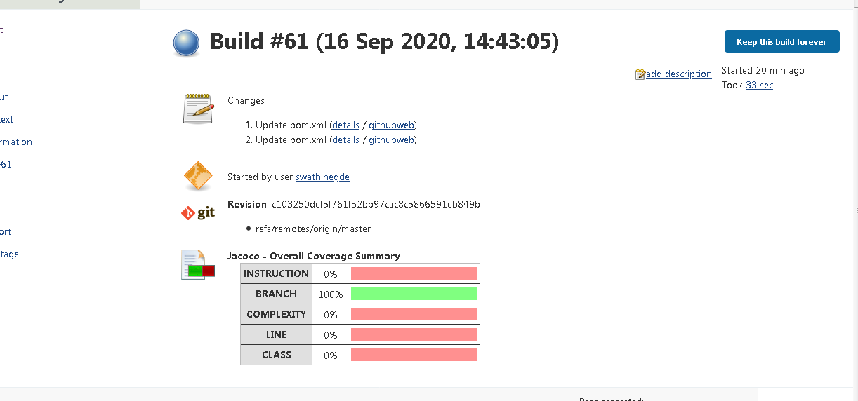

**Output from Sonar**

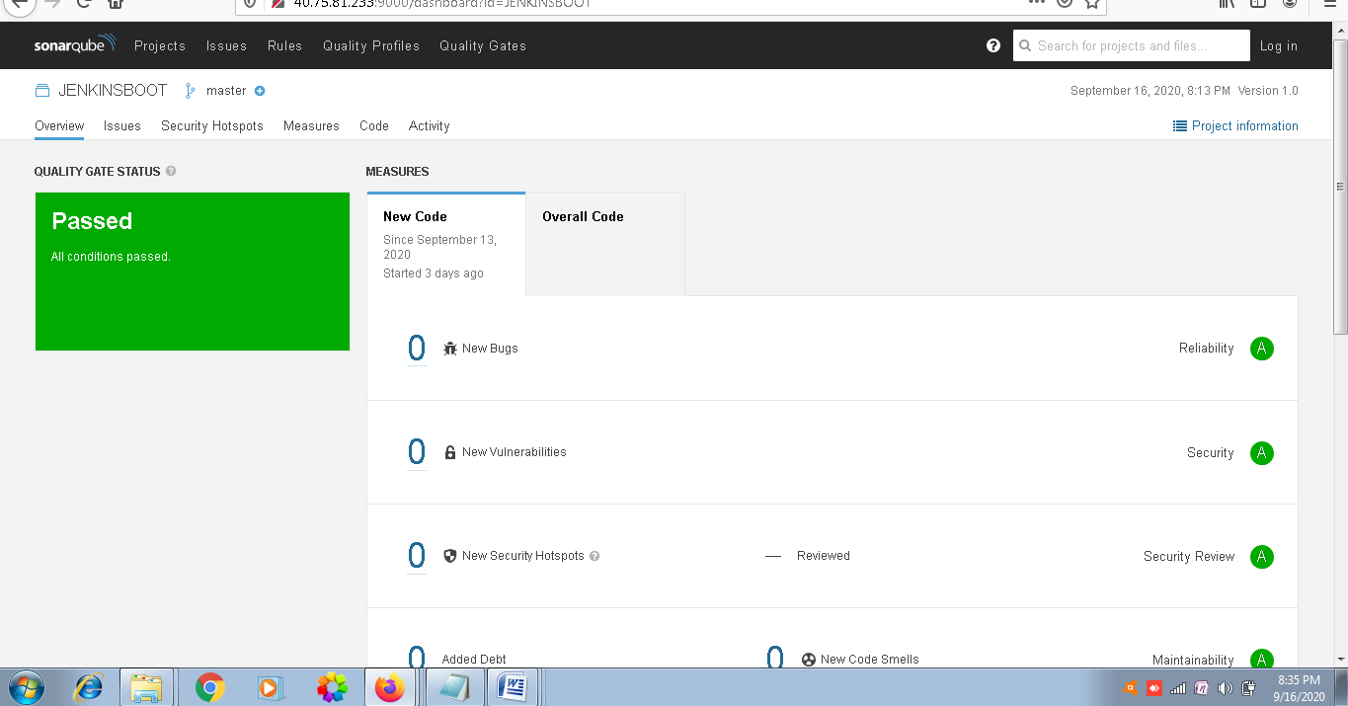

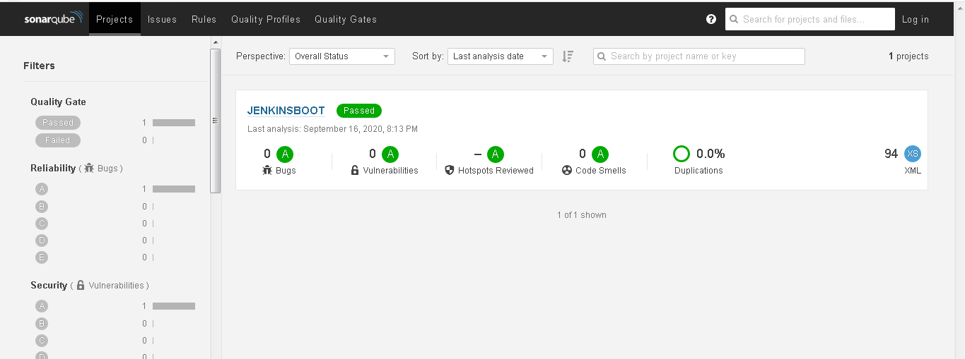

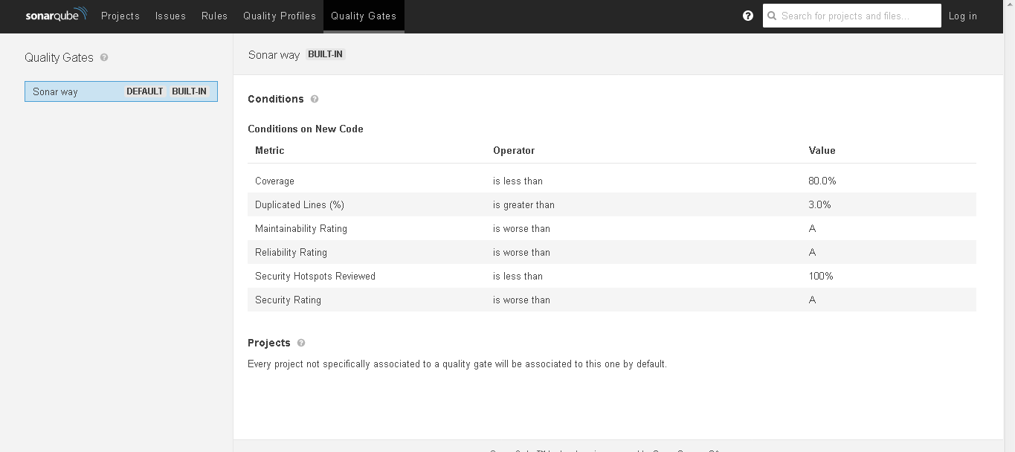

**Please find the screenshots of the artifacts which was deployed thru pipeline script to artifactory**

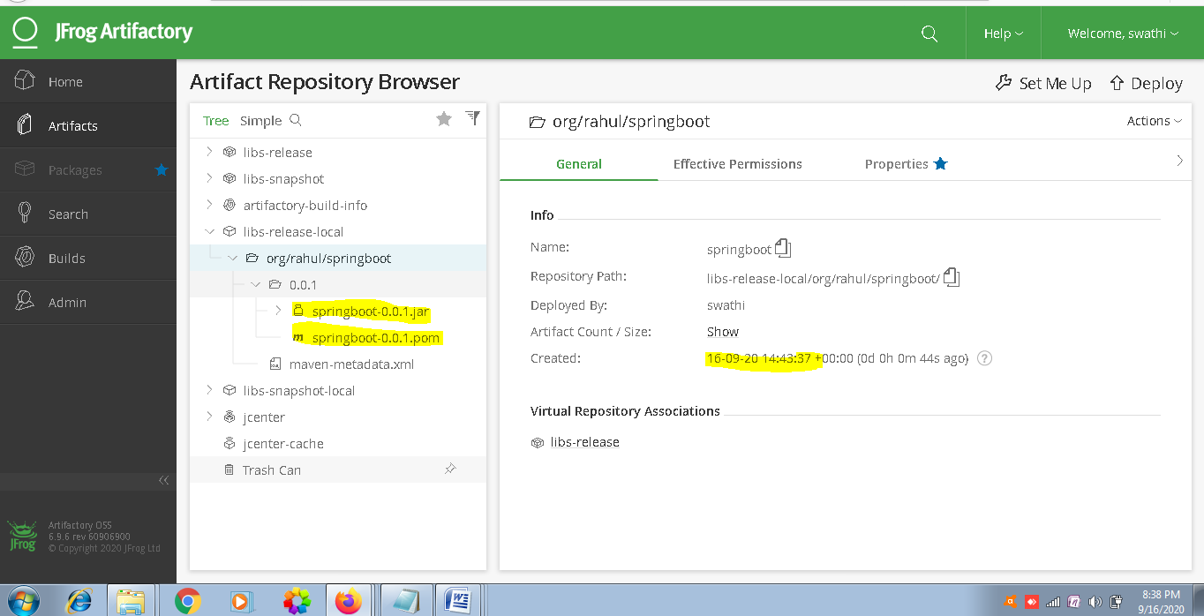

**Now I will create another job to deploy artifacts from Artifactory to slave qaenvironment**

**Before that we will be installing copy artifact plugin**

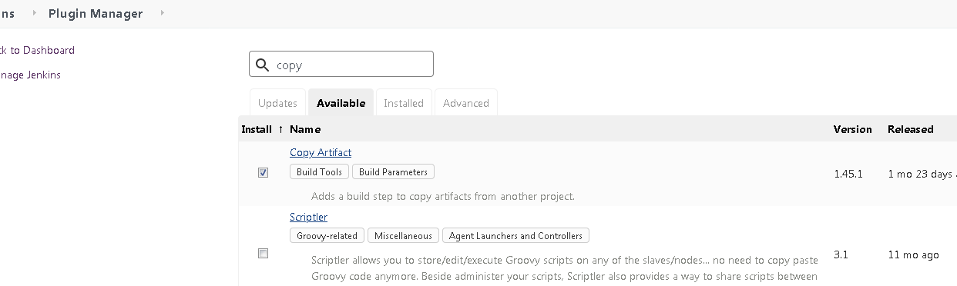

**Also we will setup docker proxy as follows**

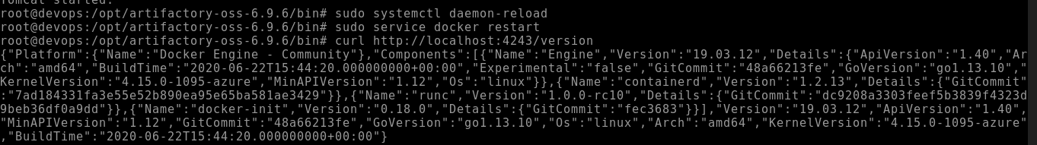

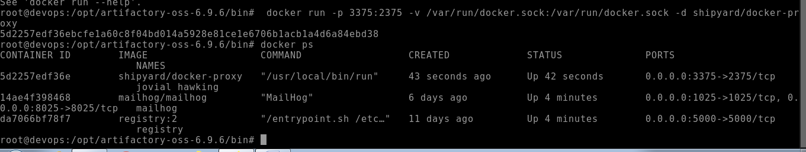

**After running the job we could see that the slave node is running as below**

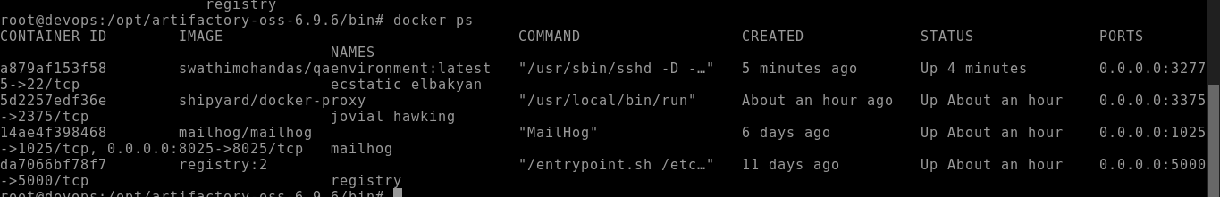

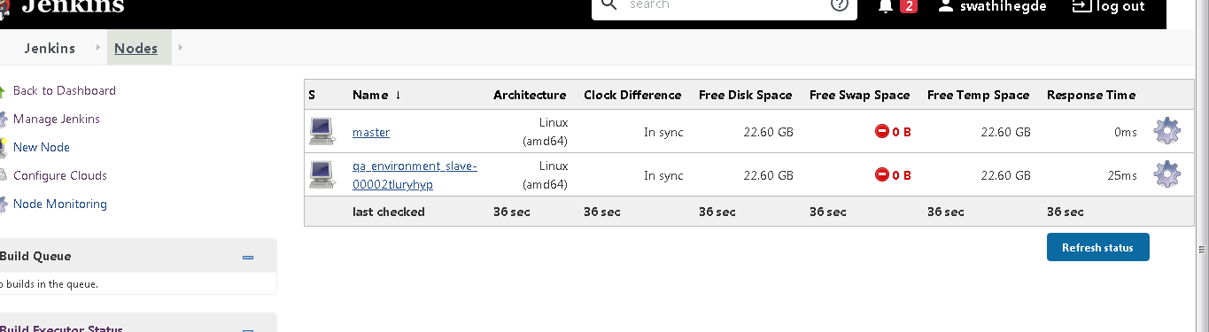

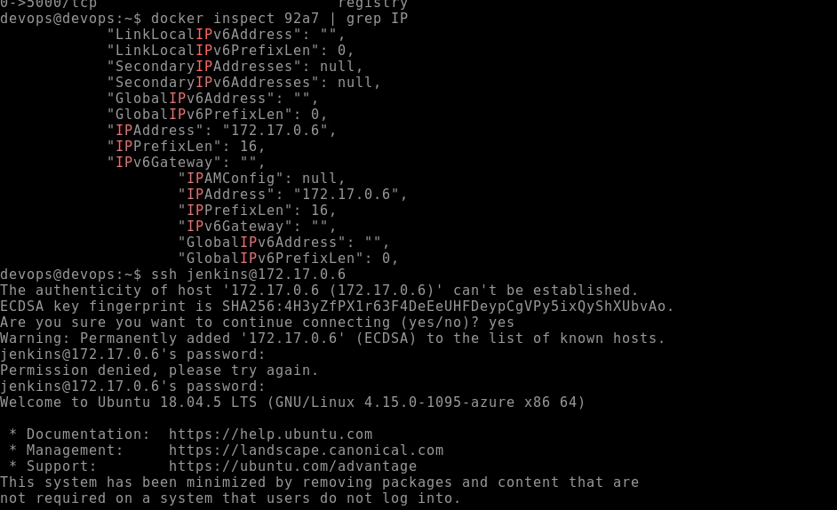

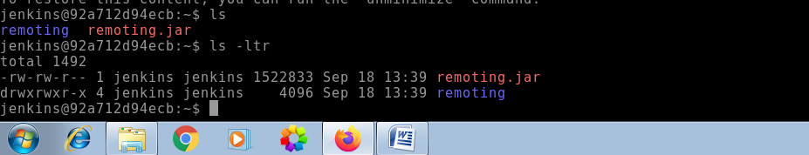

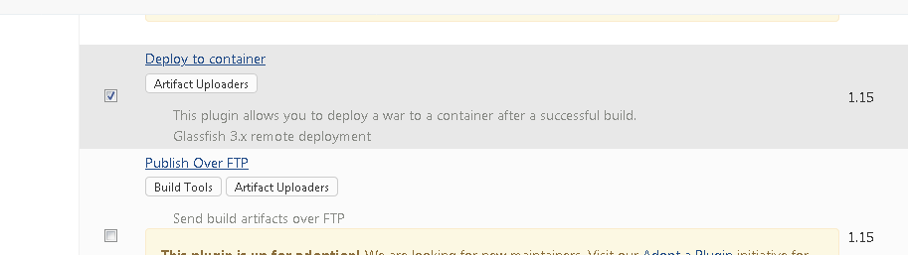

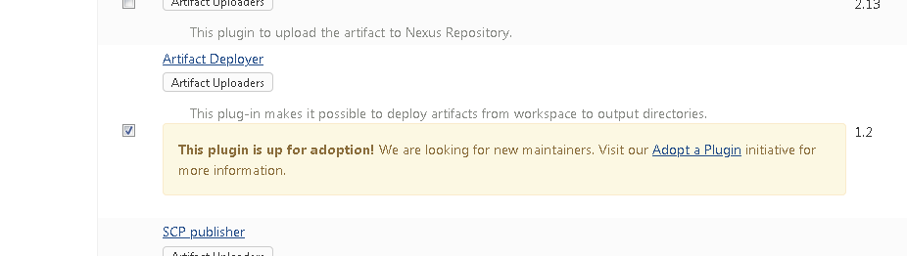

**\*\*\*\*\*\*\*\*\*\*\*\*\*\*\*\*\*\*\*\*\*\*\*\*\*\*\*\*\*\*\*\*\*\*\*\*\*\*\*\*\*\*\*\*\*\*\*\*\*\*\*\*\*\*\*\*\*\*\*\*\*\*\*\*\*\*\*\*\*\*\*\*\*\*\*\*\*\*\*\*\*\*\*\***

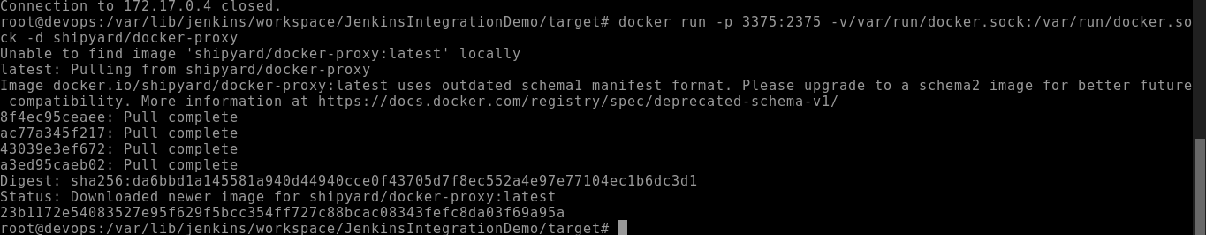

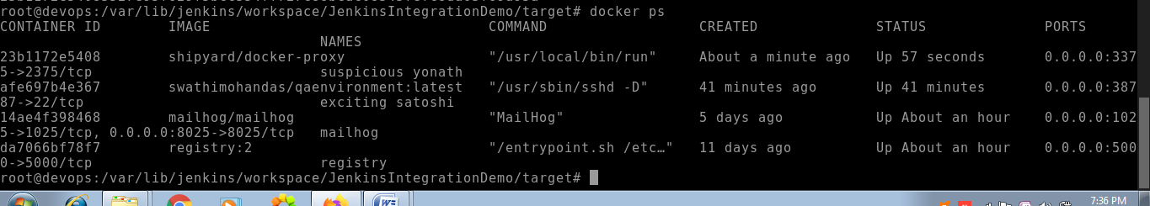

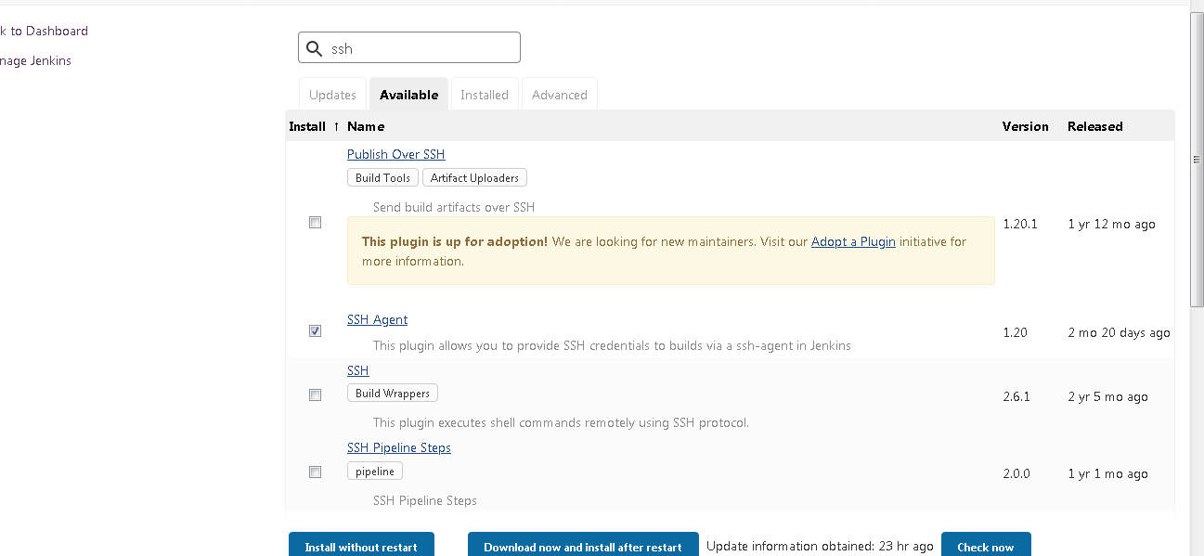

Now we will be creating a dowstream job to download artifacts from Jfrog and host it to qa_env

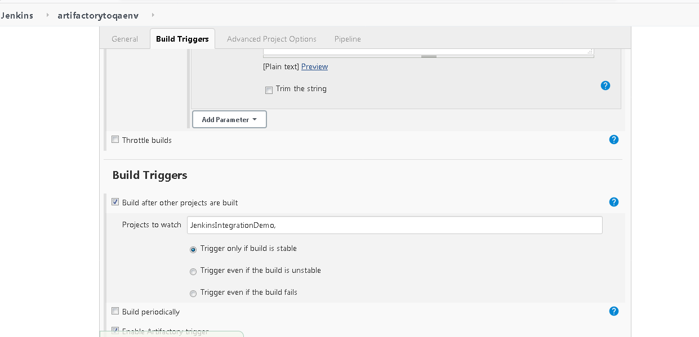

Now we could see that once the upstream job (i.e Jenkins IntegrationDemo Job is completed the downstream job is triggered which will be launching the slave node in our server.

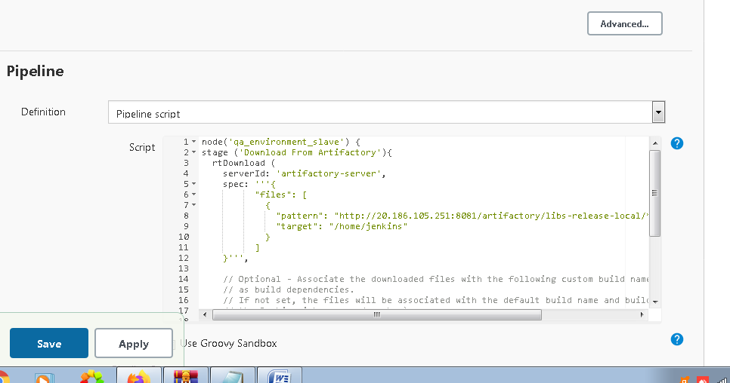

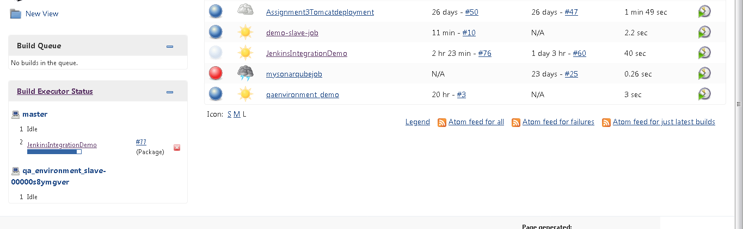

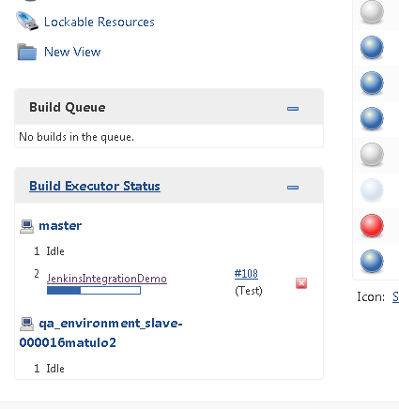

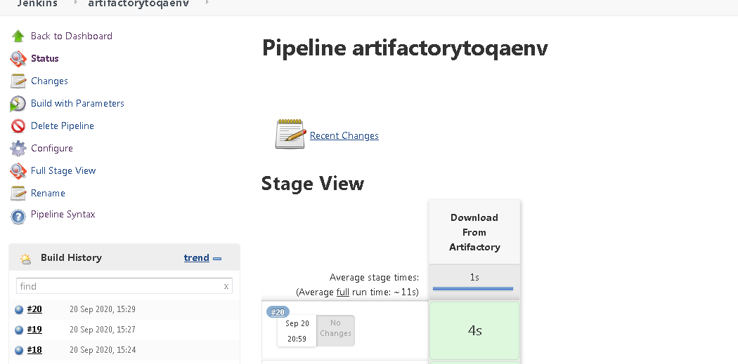

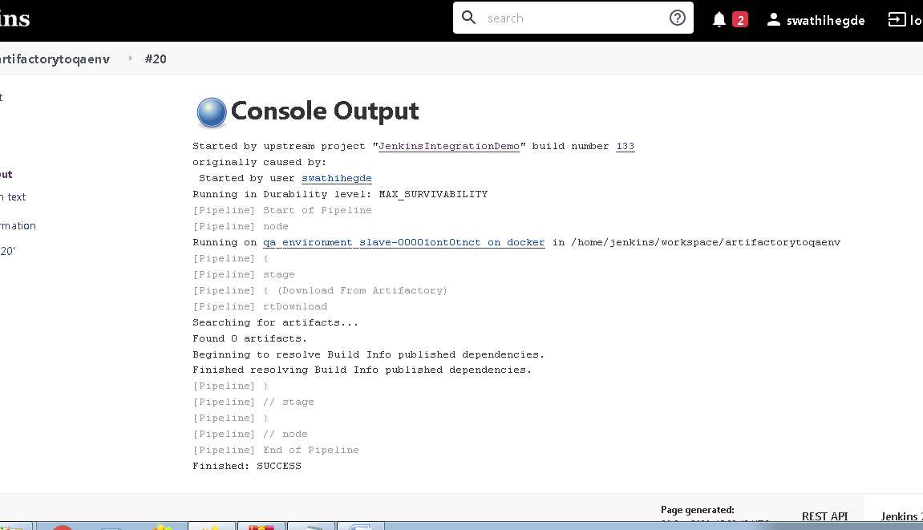

**To trigger the job once there is a commit in github repository**

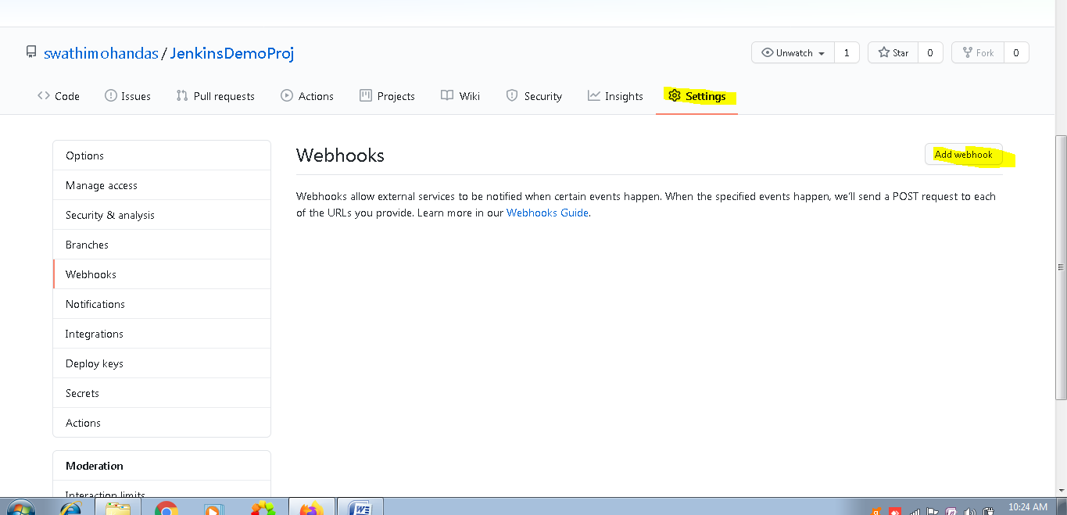

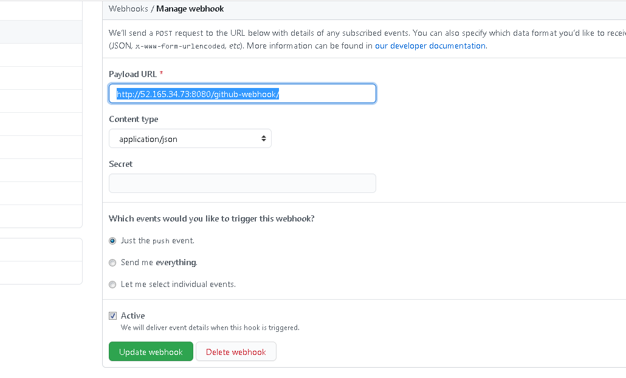

**For email triggers in case of Build failure we will do as follows.**

**In Jenkins pipeline script we will add this scipt for sending the email for any build failure.**

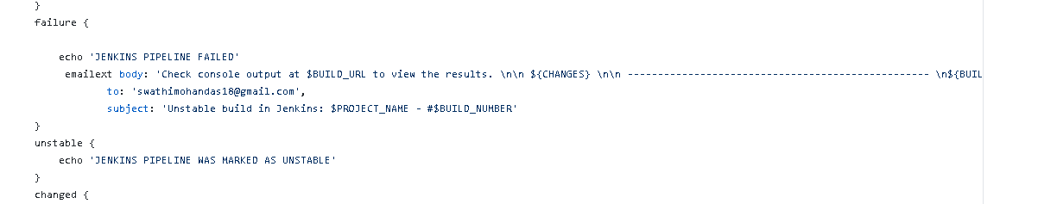

**We will now be fail the build and check if email is triggered**

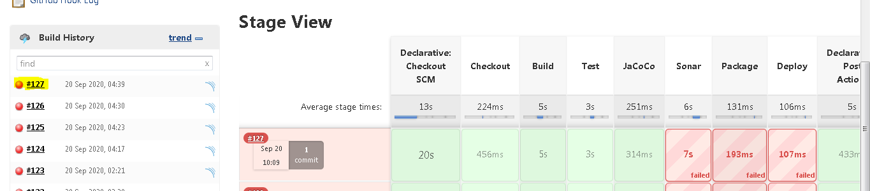

**We could see that above build 127 is failed now**

**Now go and check email in mail hog**

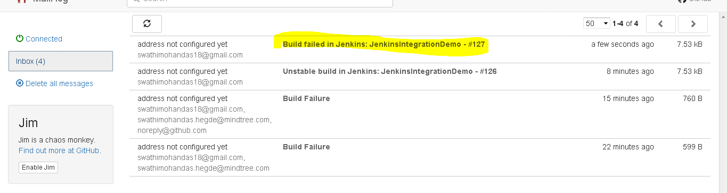

**We could see the console output in email as follows**

